University of St. La Salle
Graduate School Lifecycle Portal
Demonstration Walkthrough & Demo Kit
A step-by-step guide for demonstrating the graduate student lifecycle:
admission handoff • course offering & adjustment • enrollment • research & defense • practicum • graduation • standing changes
Every demo account password is: DemoPass123!

1. About the System
The Graduate School Lifecycle Portal is a web application that gives the University of St. La Salle (USLS) Graduate School a single, consolidated workspace for monitoring and coordinating the full graduate student lifecycle. It replaces the manual, spreadsheet-only process the Graduate School currently uses to track where each student stands.
The application does not replace AIMS, the university's official academic information system. AIMS remains the official source for student identity, enrollment, enrolled subjects, grades, and course completion. Authorized staff export an approved monitoring workbook and import it here; those official values are shown as read-only and are labeled with their source. The portal adds the coordination, decision-support, and exception-reporting layer on top of that official data.
What the portal lets staff do
- Import the Academic Coordinator monitoring sheet and reconcile it into a single student list.
- Set up the subjects offered for a specific semester, together with the schedule and the assigned faculty member.
- Tag students as enrolled in offered subjects, either by uploading a class list or by searching a single student.
- Identify which subjects are needed next term and which students are affected if a subject is not offered.
- Route research submissions, panel matching, and defense scheduling for each student.
- Process standing changes: subject withdrawal, leave of absence, readmission, AWOL, and residency.
- Track graduation eligibility and prepare the Dean-approved endorsement list.

2. System Requirements
To run the demonstration smoothly, the presenting machine should meet the following:
- A modern browser (Google Chrome or Microsoft Edge recommended), kept up to date.
- At least 4 GB of RAM and a few GB of free disk space for the local database and demo files.
- Python 3 and Node.js installed, so the backend server and the built front-end can run locally.
- The demonstration runs locally on the presenter's machine; a live internet connection is only needed for the optional Policy Assistant feature.

3. Before You Start (Setup Notes)
Note: On the first start, the system automatically prepares its demonstration database and seeds all of the demo accounts and sample records described in this document. This runs once and may take a short moment. If a demo account or the login dropdown ever appears empty, restarting the server re-seeds the demonstration data.
Start-up sequence (performed once before the demo):
Step 1. Build the front-end so the latest screens are served.
Step 2. Start the application server. The system seeds the demonstration data automatically on first run.
Step 3. Open the application in the browser at the local address shown when the server starts (the portal runs on port 5050).
Step 4. You will land on the Login screen. Use the accounts in Section 4.
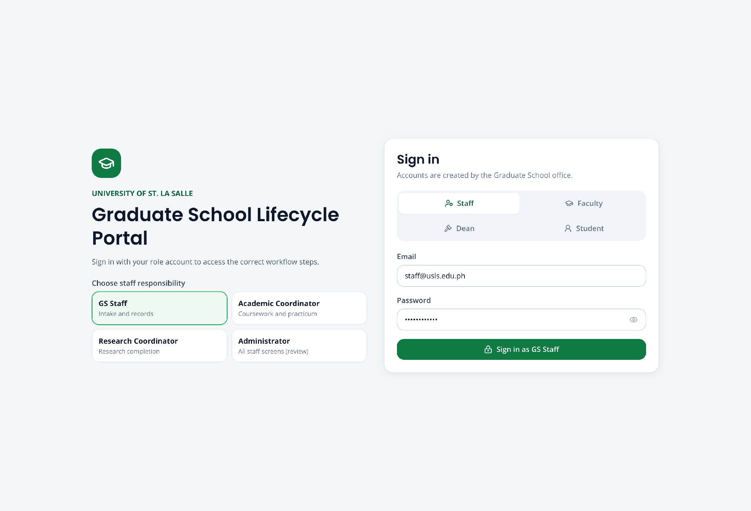
Screenshot — The Login screen, showing the account-type selector and the demo-account shortcuts.

4. Demo Accounts
Every account below uses the same password: DemoPass123! On the Login screen, choose the matching account type (role), enter the email and password, then click Log in. Student demo accounts can also be selected from the demo shortcuts on the Login screen.
Staff and approver accounts
Role | Name | Email (username)
Graduate School Staff | Grace Fernandez | staff@usls.edu.ph
Academic Coordinator | Dr. Ramon Alvarez | academic@usls.edu.ph
Research Coordinator | Dr. Sofia Mendoza | research@usls.edu.ph
Dean (approver) | Graduate School Dean | dean@usls.edu.ph
Registrar (external handoff) | Registrar Office | registrar@usls.edu.ph
Administrator | System Administrator | admin@usls.edu.ph
Student demo accounts (one ready for each scenario)
Student | Student No. | Email | Ready for
Miguel Yu | 2260004 | student@usls.edu.ph | Research, Panel, Defense
Sofia Reyes | GS-2026-HO-01 | handoff.sofia@usls.edu.ph | Complete student handoff
Anton Bautista | GS-2026-HO-02 | anton.bautista@student.usls.edu.ph | Handoff follow-up
Lianne Mercado | GS-2026-CA-01 | adjustments.lianne@usls.edu.ph | Course-demand example
Roberto Aquino | GS-2026-CA-02 | roberto.aquino@student.usls.edu.ph | Focused subject needs
Clarissa Dela Cruz | GS-2026-ENR-01 | enrollment.clarissa@usls.edu.ph | Single-student enrollment
Martin Gonzales | GS-2026-ENR-02 | enrollment.martin@usls.edu.ph | Offered-subject enrollment
Elena Navarro | GS-2026-WD-01 | withdrawal.elena@usls.edu.ph | Subject withdrawal (MAED-MAJ1)
Joshua Lim | GS-2026-WD-02 | withdrawal.joshua@usls.edu.ph | Subject withdrawal (MAED-MAJ2)
Andrea Villanueva | GS-2026-PRAC-01 | practicum.andrea@usls.edu.ph | Practicum
Bianca Santos | GS-2026-GRAD-01 | graduation.bianca@usls.edu.ph | Graduation application
Maureen Castillo | GS-2026-LOA-01 | maureen.castillo@student.usls.edu.ph | One-semester Leave of Absence
Daniel Fernandez | GS-2026-LOA-02 | loa.daniel@usls.edu.ph | Two-semester LOA policy check
Therese Lacson | GS-2026-READ-01 | readmission.therese@usls.edu.ph | Readmission after approved LOA
Gabriel Domingo | GS-2026-READ-02 | readmission.gabriel@usls.edu.ph | Readmission policy checks
Maya Torres | GS-2026-AWOL-01 | awol.maya@usls.edu.ph | Return from automatic AWOL
Nicolas Valdez | GS-2026-RES-01 | residency.nicolas@usls.edu.ph | Residency policy review
Note: Additional seeded students exist for handoff, course adjustments, readmission, AWOL, residency, and a second student for practicum and graduation, so every list and batch screen has more than one example.

5. Navigating the Portal
After logging in, the left sidebar is grouped into sections. The graduate lifecycle is presented as a numbered sequence so the demonstration can move through it in order.
Lifecycle workflows (the main demonstration path)
- 1 · Student Handoff — import and reconcile the monitoring sheet.
- 2 · Course Adjustments — set up subject offerings and review subject needs.
- 3 · Enrollment — tag students to offered subjects.
- 4 · Research Gate — check each student's required research submissions.
- 5 · Panel Matching — recommend and finalize the defense panel.
- 6 · Defense Scheduling — find a common defense slot.
- 7 · Practicum — track practicum requirements and hours.
- 8 · Graduation — check eligibility and prepare the endorsement list.
Standing changes
- Leave of Absence
- Readmission
- AWOL & Residency
- Withdrawal Requests
Records and support
- Students, Faculty, Monitoring Sheet, Enrollment Class List
- Dashboard and Reports
- Work Queue, Activity Log, Recommendations, and the Policy Assistant
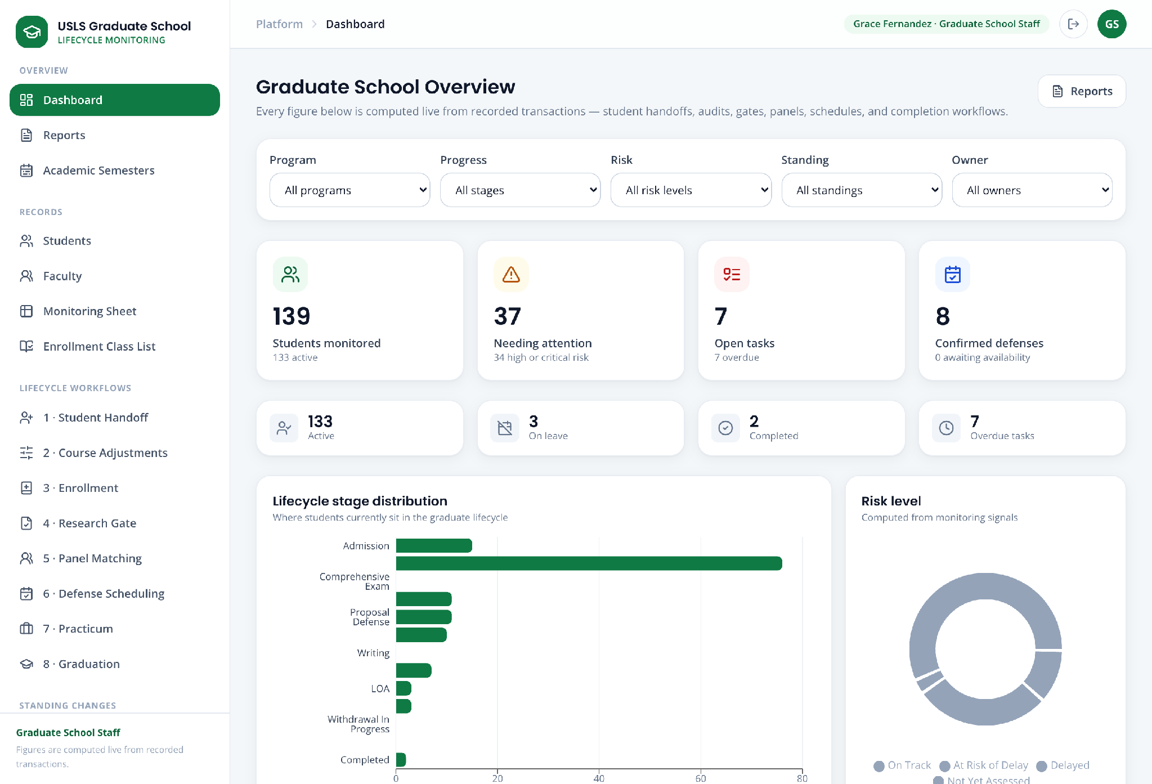
Screenshot — The dashboard after login, showing the sidebar sections and the lifecycle overview.

6. Demonstration Scenarios
Each scenario below is self-contained: it names the account to use, the story behind it, the data to enter, and the steps to follow. Run them in order for a full end-to-end demonstration, or pick individual scenarios.
Assigned-scenario coverage
The matrix below confirms where each requested screen or workflow is demonstrated. The detailed steps then follow the same sequence as the portal.
Scenario | Screens / workflows covered
1 | Student Handoff; Monitoring Sheet; Students directory and full student record
2 | Faculty Profiles; Course Adjustments — Demand & adjustments; Offering setup
3 | Enrollment; class-list import preview; Enrollment Class List; record synchronization
4 | Subject-needs report; affected students; delay impact
8 | Leave of Absence; Readmission; automatic AWOL; Return from AWOL; Residency

Scenario 1 — Import and reconcile the monitoring sheet
Story:
At the start of the term break, Graduate School Staff receive the Academic Coordinator monitoring workbook. Grace Fernandez imports it, checks the reconciliation result, and verifies that the Monitoring Sheet and Student Records show the same official source data.
Log in as:
Field | Value / Instruction
Account type | Graduate School Staff
Email | staff@usls.edu.ph
Password | DemoPass123!
Data to use:
Field | Value / Instruction
Monitoring workbook | Documents\Monitoring_Sheets\MAED_Monitoring_Sheet.xlsx
Handoff demo records | Sofia Reyes (complete) and Anton Bautista (follow-up)
Verification path | Student Handoff → Monitoring Sheet → Students
Steps:
Step 1. From the sidebar, open 1 · Student Handoff.
Step 2. Click Browse files under Import from the monitoring sheet, select the MAED workbook, then click Import students.
Step 3. Review the import summary and validation items. Existing students are updated, genuinely new students are added, and conflicting or incomplete source rows remain visible for reconciliation.
Step 4. Review Upload history. Each workbook version is preserved with its time, file name, counts, validation result, and conflict record.
Step 5. Open Monitoring Sheet. Choose MAED and the relevant semester, use the progress/risk/enrollment filters, and verify the read-only curriculum grid. Use Flag issue to record a discrepancy without overwriting the source.
Step 6. Open Students, search for Sofia Reyes or Anton Bautista, and open the full student record. Verify identity, program, standing, enrollment, coursework, tasks, activity, and source references.
Step 7. If an official value is wrong, correct it in the authorized source and re-import the workbook; do not manually rewrite the imported value here.
Note: The imported values (identity, program, completed subjects) are read-only and labeled with their source. If a value looks wrong, staff use Flag issue to record a discrepancy — the portal never edits an official value directly.
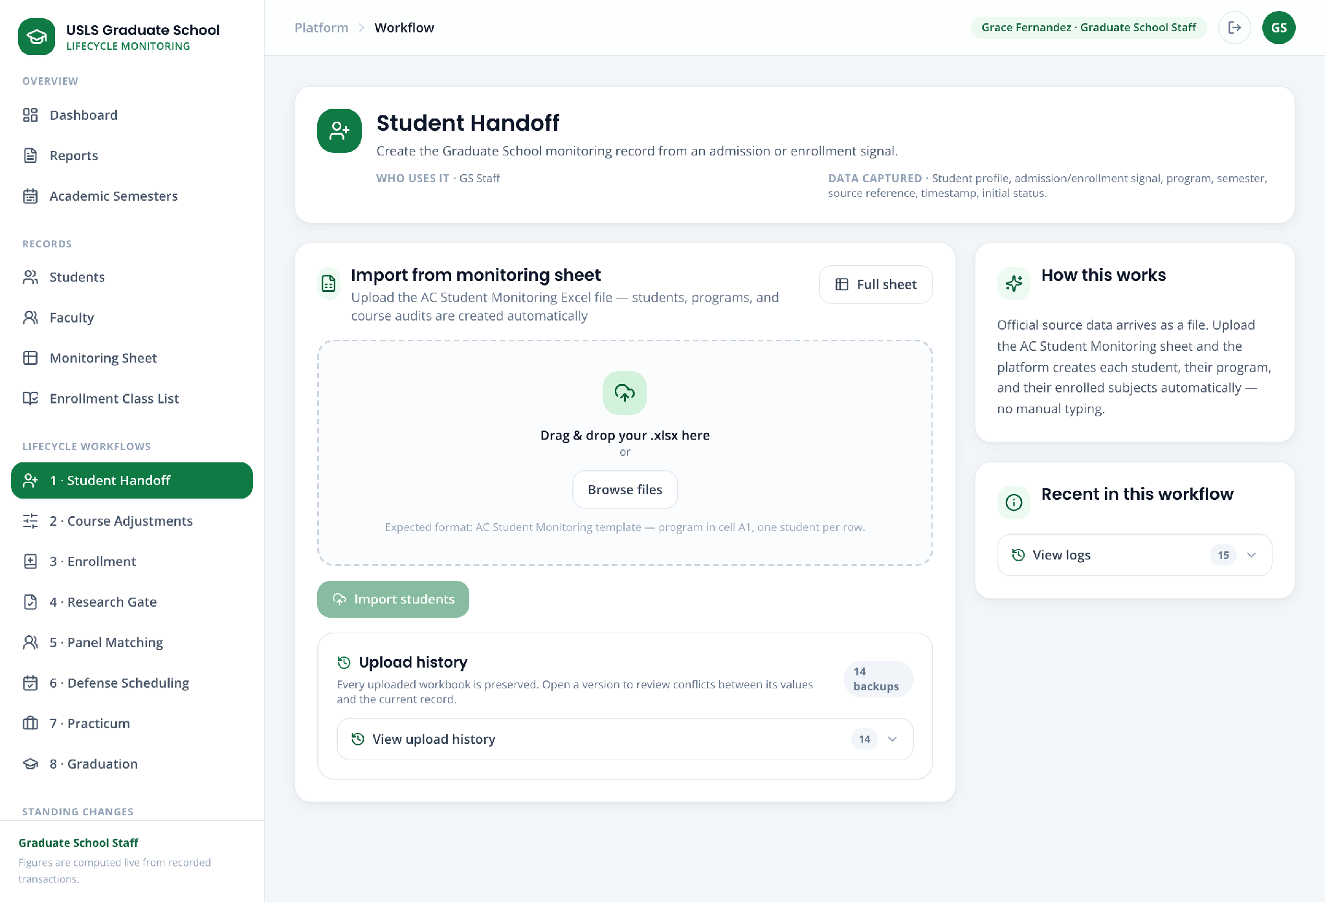
Screenshot — Student Handoff showing the monitoring-sheet importer and upload-history panel.
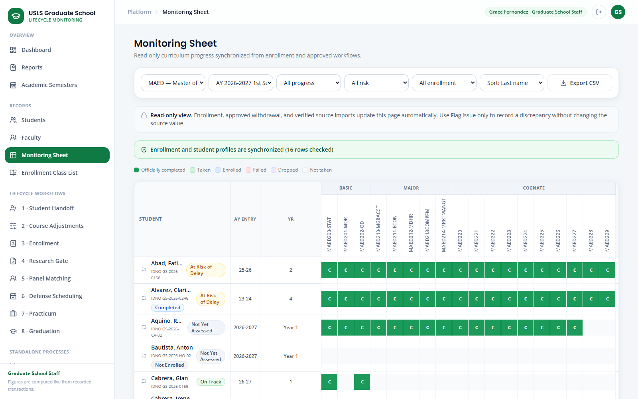
Screenshot — The read-only Monitoring Sheet with program, semester, progress, risk, and enrollment filters.
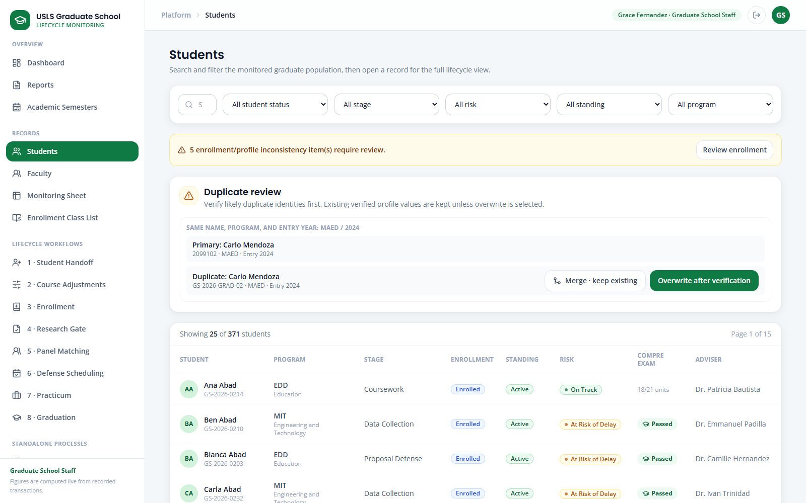
Screenshot — Student Records, where staff can search the directory and open a complete lifecycle record.

Scenario 2 — Review faculty records and set up semester offerings
Story:
Before enrollment opens, Academic Coordinator Dr. Ramon Alvarez reviews faculty profiles, studies live subject demand, decides what to offer, routes the plan for approval, publishes it, and completes each offering's faculty, schedule, and section.
Accounts used:
Field | Value / Instruction
Coordinator | academic@usls.edu.ph
Approver | dean@usls.edu.ph
Password | DemoPass123! for both accounts
Data to use:
Field | Value / Instruction
Program | MAED — Master of Arts in Education
Planning semester | AY 2026–2027, 1st Semester (Current)
Subject | Choose a MAED subject surfaced by the demand report
Schedule | Example: Saturday, 8:00–11:00
Faculty | Choose after reviewing the faculty profile and workload
Steps:
Step 1. Open Faculty. Search for a faculty member, open the profile, and review specialization, preferred teaching subjects, login email, current load, weekly availability, and calendar source.
Step 2. Open 2 · Course Adjustments and stay on Demand & adjustments. Select MAED and the planning semester.
Step 3. Review the automatically calculated subject needs and affected-student counts. These figures support the decision; they do not publish a subject or assign faculty automatically.
Step 4. Mark the chosen subjects as offered, set the section count and faculty choice, then click Save draft.
Step 5. Click Submit for approval. Sign in as the Dean to approve or return the plan, then return as the Academic Coordinator and click Publish after approval.
Step 6. Switch to Offering setup. Complete or confirm the assigned faculty, schedule, and section for each published subject, then click Save.
Note: Faculty suggestions and preferences are advisory. The Academic Coordinator owns the final assignment, and only published official offerings become available in Enrollment.
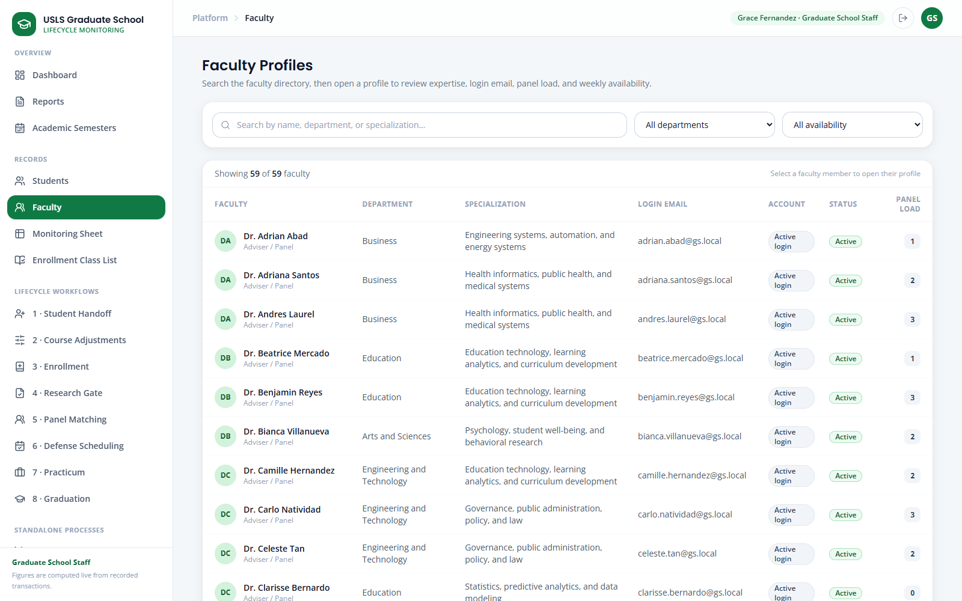
Screenshot — Faculty Profiles, including searchable expertise, login, workload, preferred subjects, and availability.
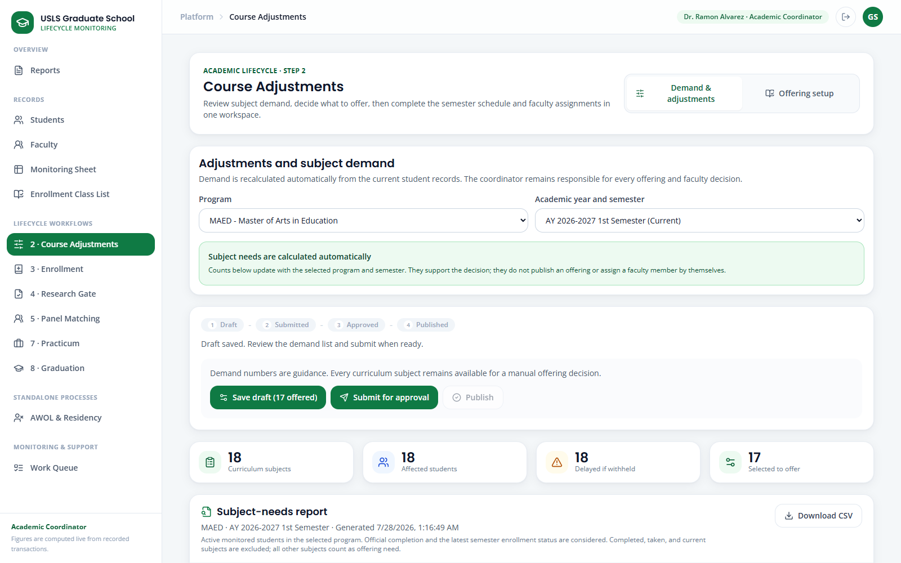
Screenshot — Course Adjustments on Demand & adjustments, showing the governed Draft → Submitted → Approved → Published flow.
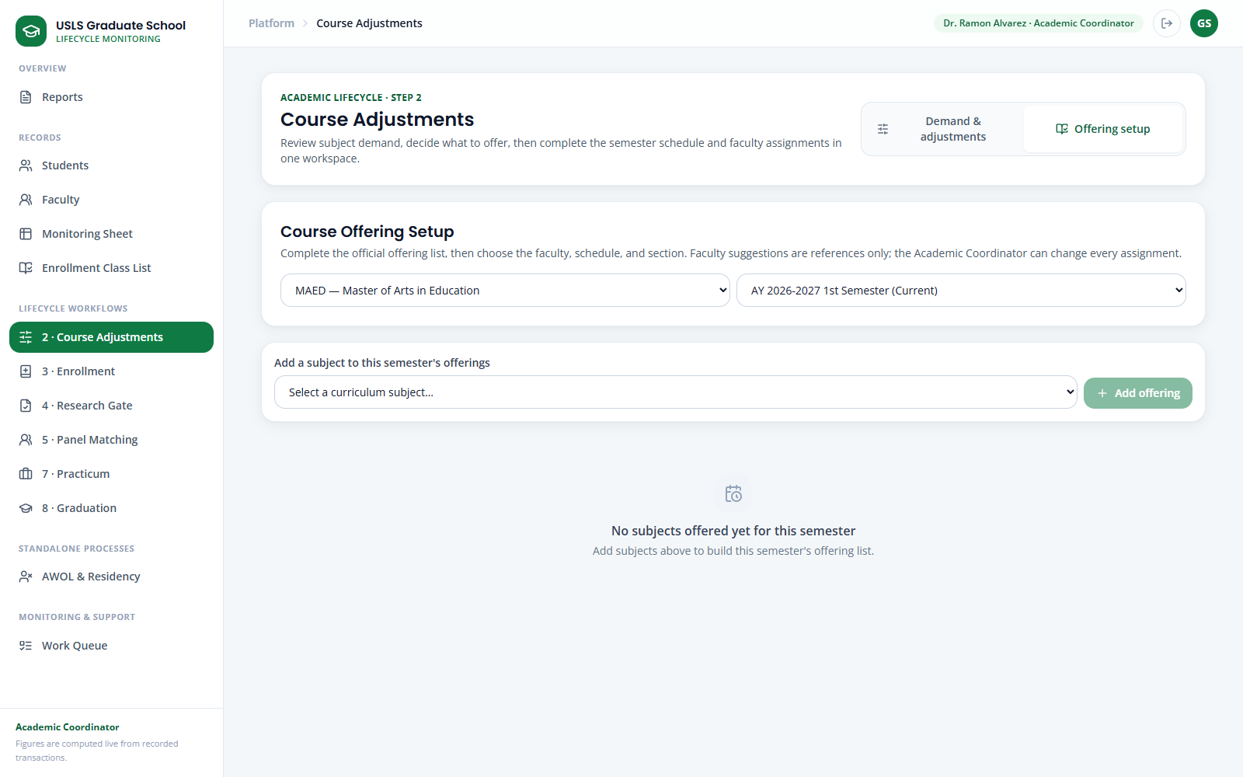
Screenshot — Offering setup, where the published subject's faculty, schedule, and section are completed.

Scenario 3 — Enroll students and verify the synchronized class list
Story:
After the offering plan is published, staff can enroll a batch from a Registrar class list or add one late student. Both paths use the same official offerings and synchronize the Enrollment Class List, Monitoring Sheet, Student Record, and Student Portal.
Log in as:
Field | Value / Instruction
Account type | Graduate School Staff
Email | staff@usls.edu.ph
Password | DemoPass123!
Data to use:
Field | Value / Instruction
Program / semester | Use the same published program and semester from Scenario 2
Class-list template | Documents\Stakeholder_Meeting_Prep\Enrollment_Class_List_Template.csv
Required matching fields | Student ID and Subject Code; Faculty may be included
Single-student demo | Clarissa Dela Cruz — GS-2026-ENR-01
Path A — Upload a class list
Step 1. Open 3 · Enrollment and confirm the Program and Academic semester.
Step 2. Click Upload class list and choose a CSV or XLSX whose Student ID and Subject Code match the published offering. Adjust the supplied template to the semester being demonstrated.
Step 3. Review the preview. Check matched rows, unknown students, subjects that are not offered, already-completed subjects, invalid faculty, and faculty conflicts before changing any record.
Step 4. Click Confirm import. Matched rows are enrolled and the source reference is recorded.
Step 5. Open Enrollment Class List. Select the program, semester, and All class lists or a single subject. Verify the read-only roster and use Export CSV if a Registrar handoff is needed.
Path B — Search and enroll one student
Step 6. Return to Enrollment, use Filter the student picker to find Clarissa Dela Cruz, and select her record.
Step 7. Select only official offered subjects that are marked Not taken, review the automatic conflict checks, enter the source/reference, and click Confirm enrollment.
Step 8. For a mid-term change, click an enrolled subject's status badge, choose Dropped or Withdrawn, and provide the required effective date and note.
Step 9. Re-open Enrollment Class List, Monitoring Sheet, and the student's full record to confirm that the same enrollment result appears on every screen.
Note: Enrollment Class List is a read-only output. All enrollment additions and status changes must be made in Enrollment or through a confirmed class-list import.
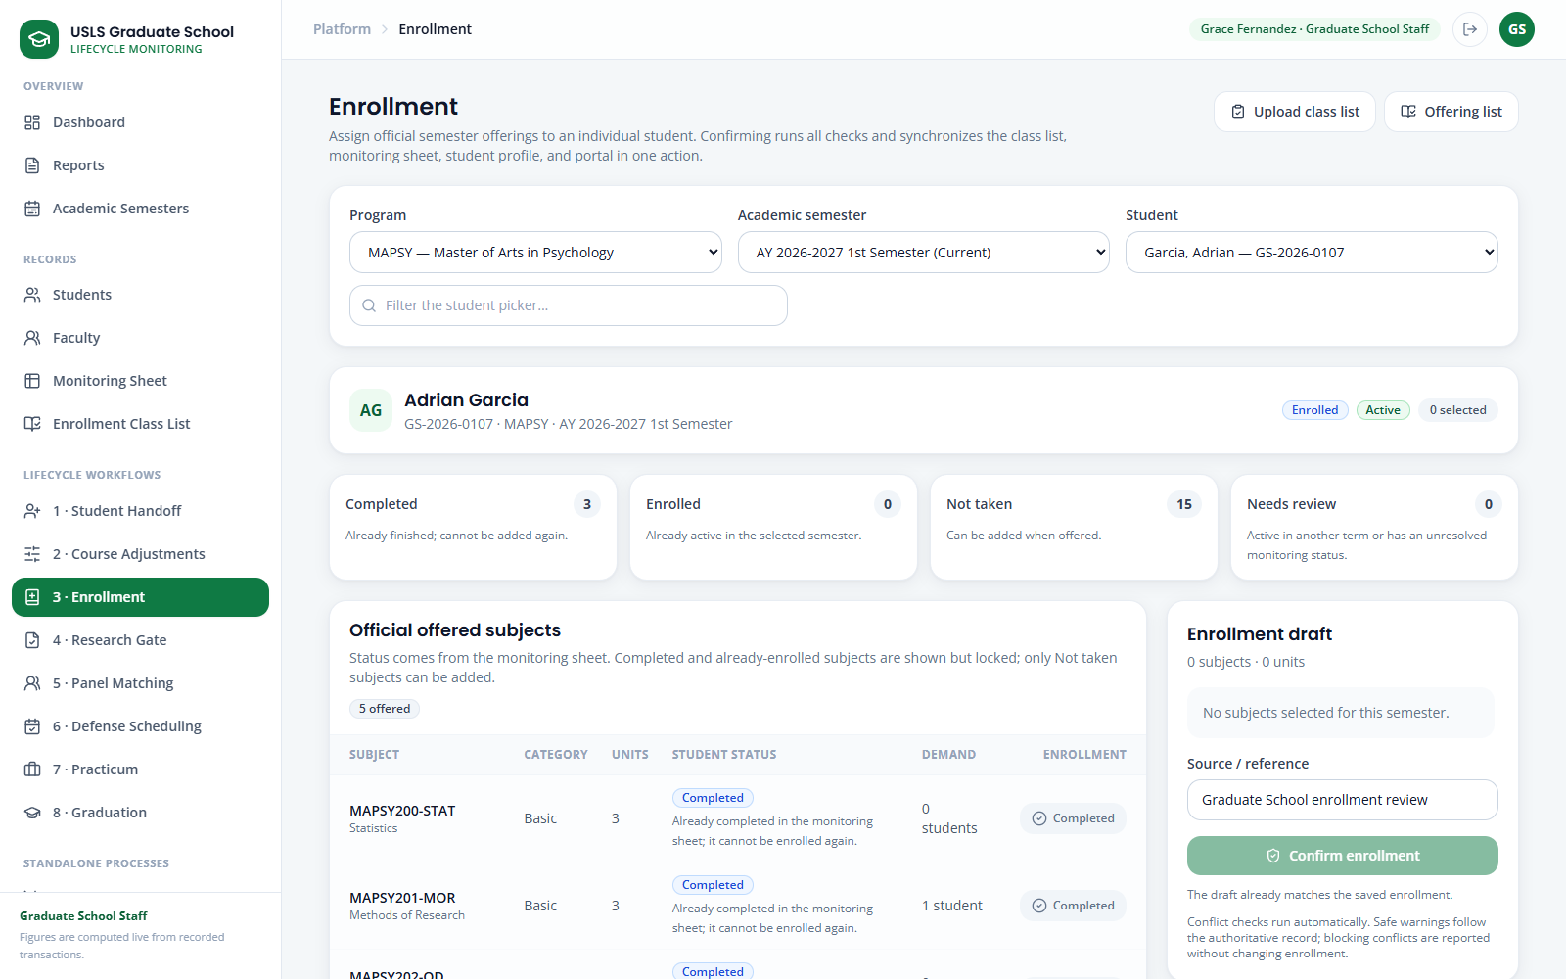
Screenshot — Enrollment showing a seeded program example with official offerings, student status checks, and a conflict-checked draft.
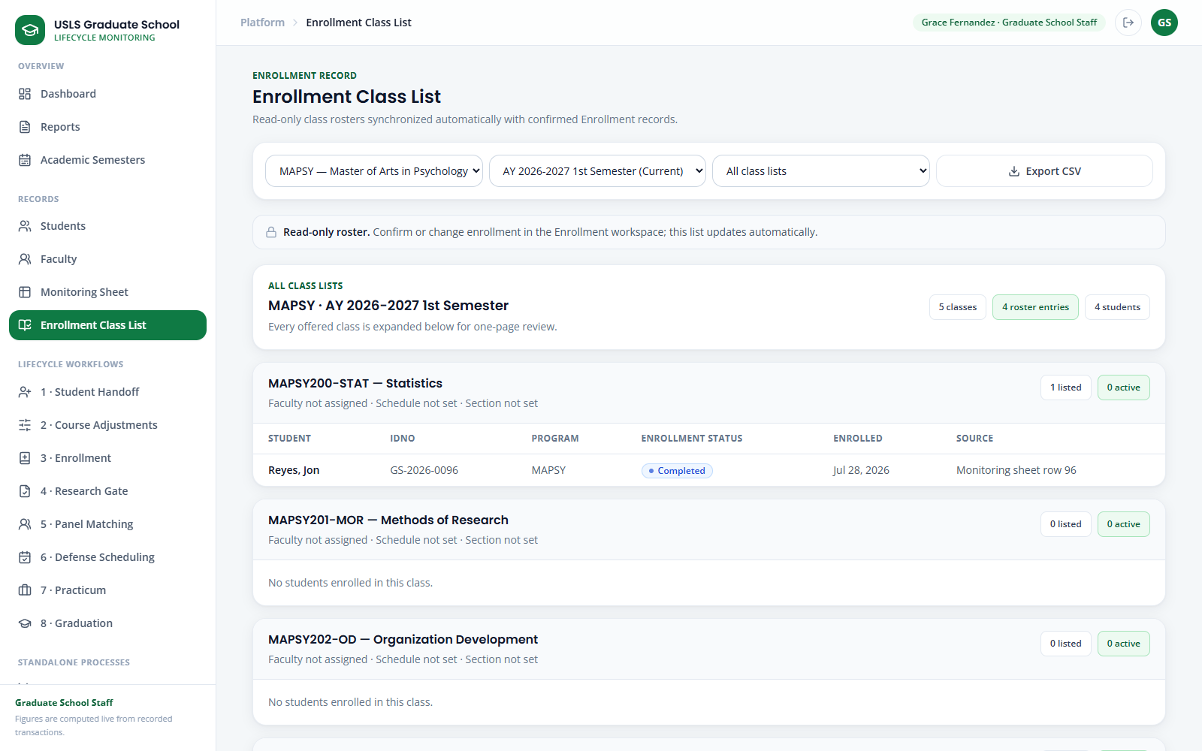
Screenshot — Enrollment Class List showing enrollment-synchronized, read-only class rosters and CSV export.

Scenario 4 — See which subjects are needed and who will be affected
Story:
The Academic Coordinator needs evidence for the next offering decision. The Subject-needs report calculates remaining requirements from current student records and identifies each student who may be delayed if a subject is withheld.
Log in as:
Field | Value / Instruction
Account type | Academic Coordinator
Email | academic@usls.edu.ph
Password | DemoPass123!
Steps:
Step 1. Open 2 · Course Adjustments and select Demand & adjustments.
Step 2. Choose the Program and planning semester. Review Students reviewed, Subjects with need, and Student-subject needs.
Step 3. In the Subject-needs report, compare Students needing with Not taken. Completed, taken, and currently enrolled subjects are excluded.
Step 4. Read the Affected students column for the names, student numbers, and delay impact behind the count. A single student need is enough to surface a subject.
Step 5. Use the evidence to revise the offering draft, then follow the submit → Dean approval → publish sequence from Scenario 2.
Note: The report is recalculated from current records; it is decision support, not an automatic offering or faculty assignment.
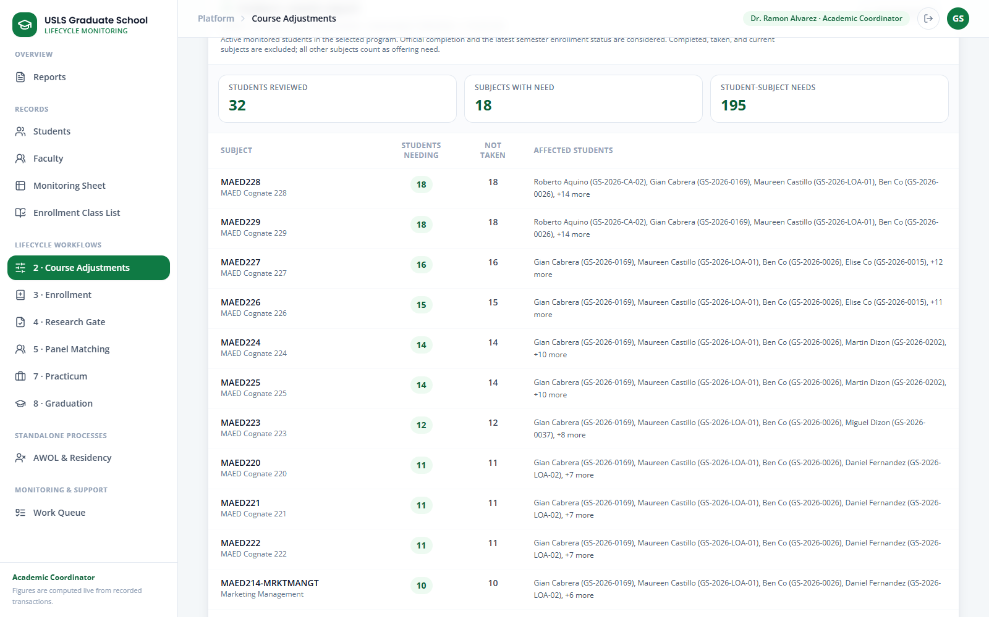
Screenshot — The Subject-needs report with counts and the named affected students behind each offering decision.

Scenario 5 — Subject Withdrawal
Story:
Elena Navarro requests to withdraw from one enrolled subject before classes begin or during the first seven calendar days of class. GS Staff forwards the request, the Dean approves it, and GS Staff tags only the selected subject as Withdrawn. The student remains Active, the other subjects remain unchanged, and the withdrawn subject produces no grade, academic penalty, or adverse transcript mark.
Joshua Lim demonstrates the unusual case: the Dean denies his request. The system preserves his enrollment, prevents the subject-withdrawal tagging and export steps, and informs him of the decision.

Role | Account
Approved-case student | withdrawal.elena@usls.edu.ph
Denied-case student | withdrawal.joshua@usls.edu.ph
Graduate School Staff | staff@usls.edu.ph
Dean | dean@usls.edu.ph
Optional enrollment verification | academic@usls.edu.ph
Suggested sample information
Elena
- Subject: MAED-MAJ1
- Reason: I need to revise my first-semester study load before the withdrawal deadline.
Joshua
- Subject: MAED-MAJ2
- Reason: I no longer want to attend this subject.
- Dean denial reason: The stated reason does not meet the approved grounds for subject withdrawal.
Part 1 - Approved withdrawal
Step 1. On the login page, open Standalone processes → Withdrawal and reset Elena Navarro’s demo.
Step 2. Sign in as Elena and open Subject Withdrawal.
Step 3. Review the Penalty-free withdrawal window notice. Confirm that it states that withdrawal is allowed before classes or during the first seven calendar days of class.
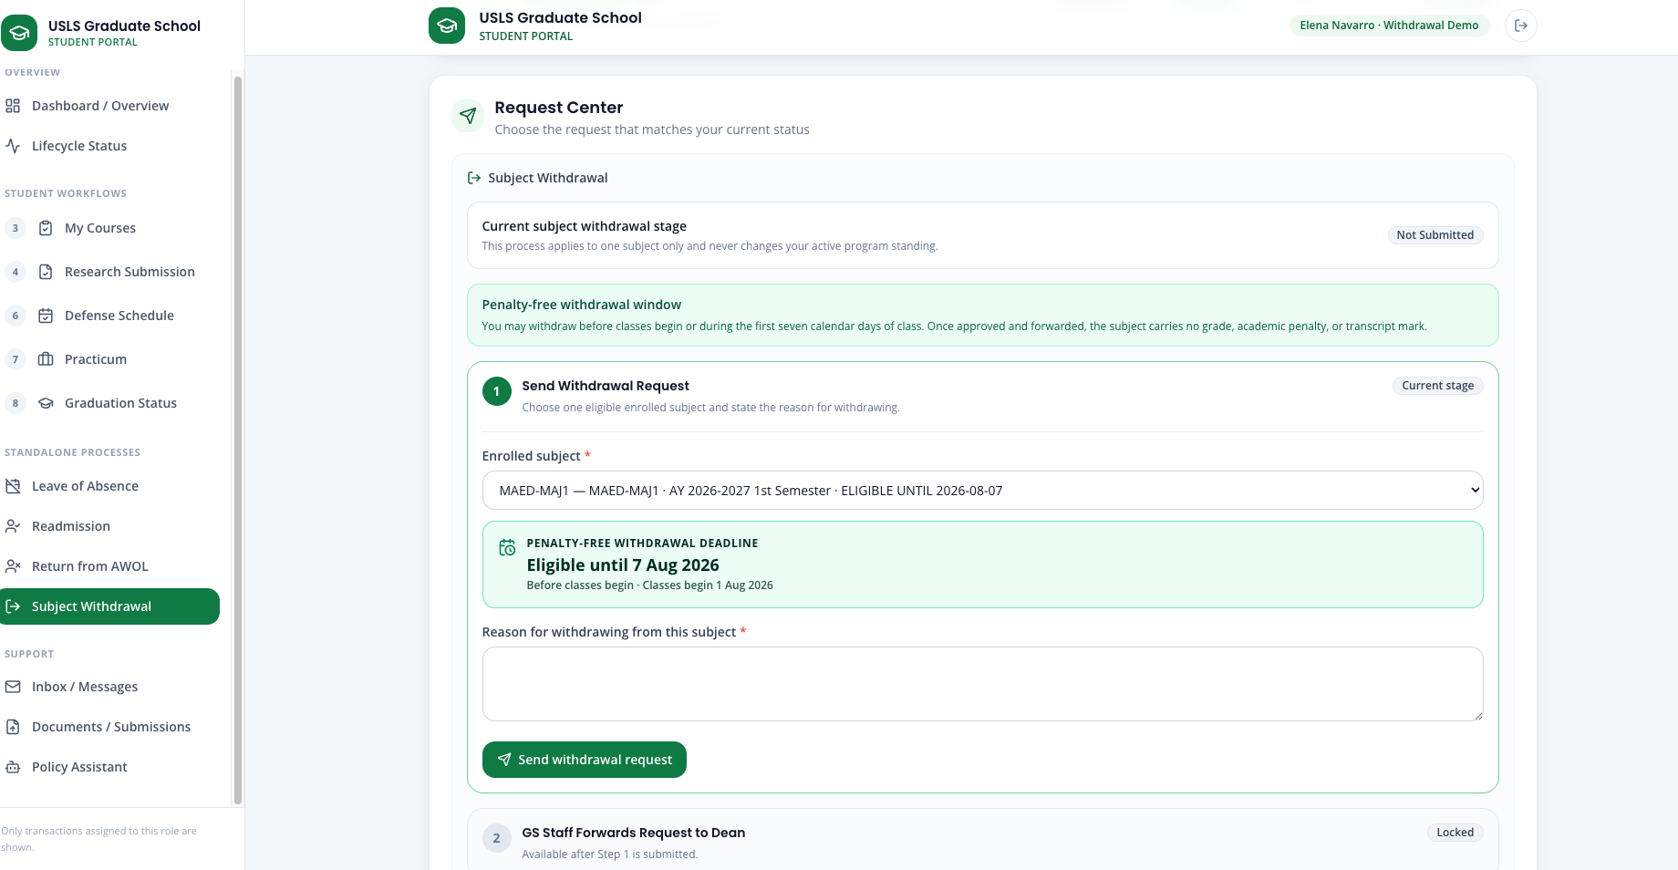
Step 4. Open the subject dropdown and select MAED-MAJ1.
Step 5. Confirm that the selected subject prominently shows Eligible until [displayed deadline].
Step 6. Enter Elena’s reason. Do not upload a PDF because the current Withdrawal process uses a structured form and requires no document.
Step 7. Select Send withdrawal request.
Step 8. Confirm that the student workflow shows Step 1 · Send Withdrawal Request as complete and Step 2 · GS Staff Forwards Request to Dean as pending.
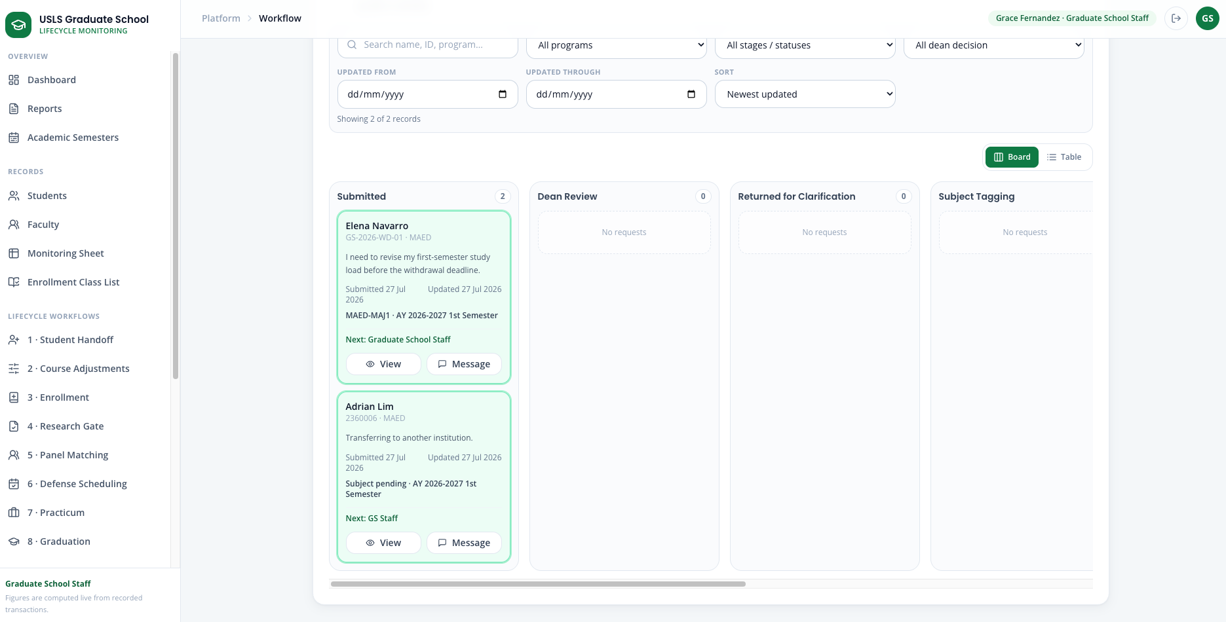
Step 9. Sign in as GS Staff and open Standalone processes → Withdrawal.
Step 10. Open Elena’s request. Verify the selected subject, semester, reason, eligibility window, and recorded deadline.
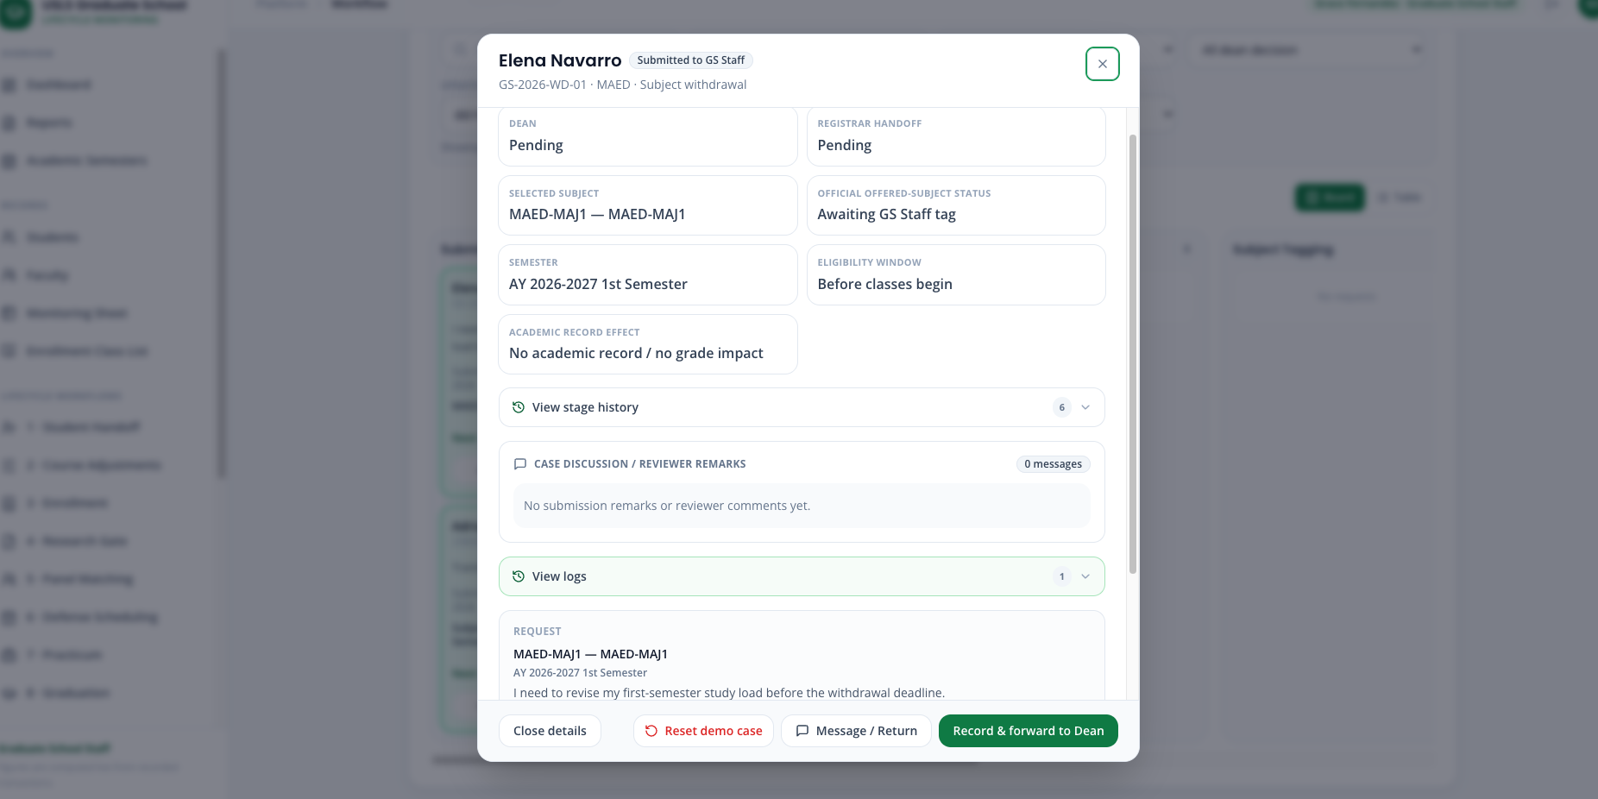
Step 11. Select Record & forward to Dean. Optionally add: The request was submitted within the recorded penalty-free withdrawal window.
Step 12. Sign in as the Dean and open Withdrawal Requests.
Step 13. Review Elena’s selected subject, request date, withdrawal deadline, reason, and workflow timeline.
Step 14. Select Approve.
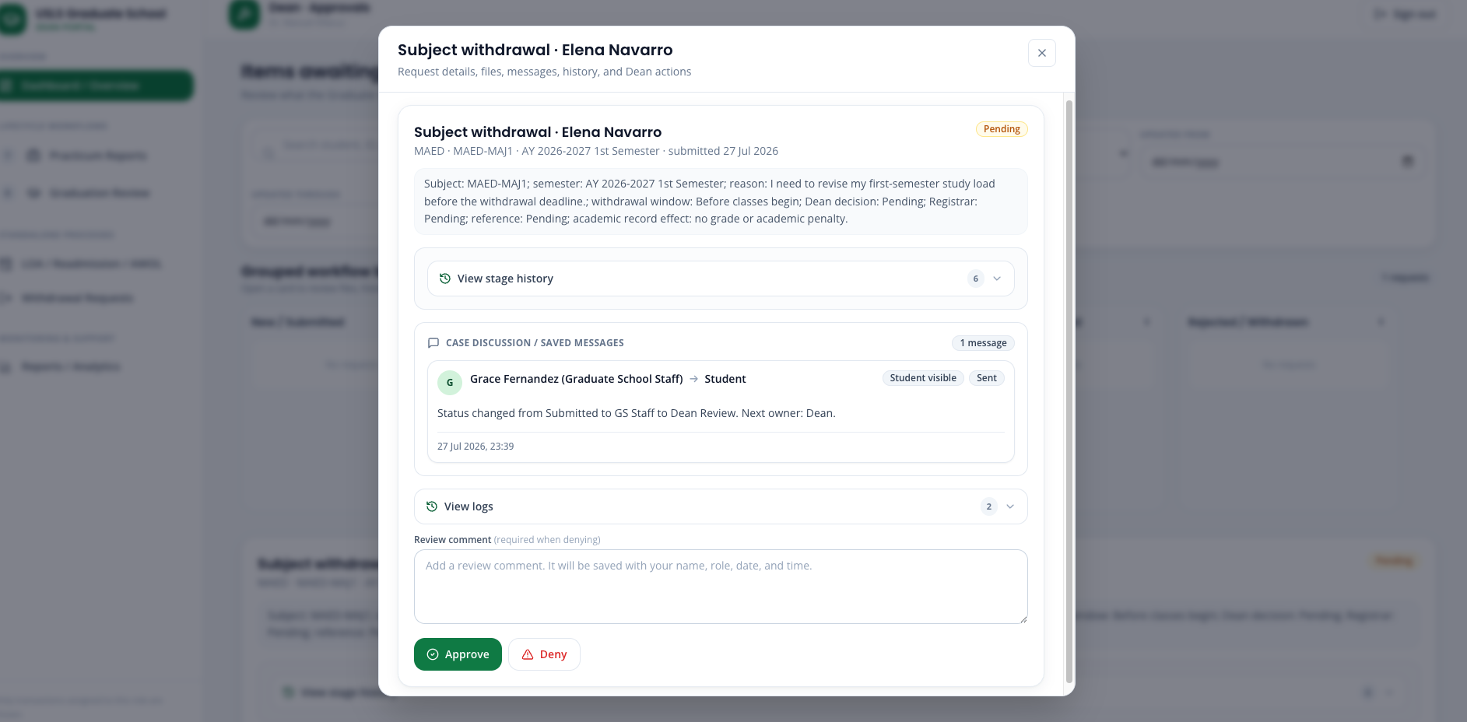
Step 15. Sign back in as GS Staff and reopen Elena’s case.
Step 16. Confirm that the case status is Approved — Awaiting Subject Tag and that the selected subject is still enrolled at this point.
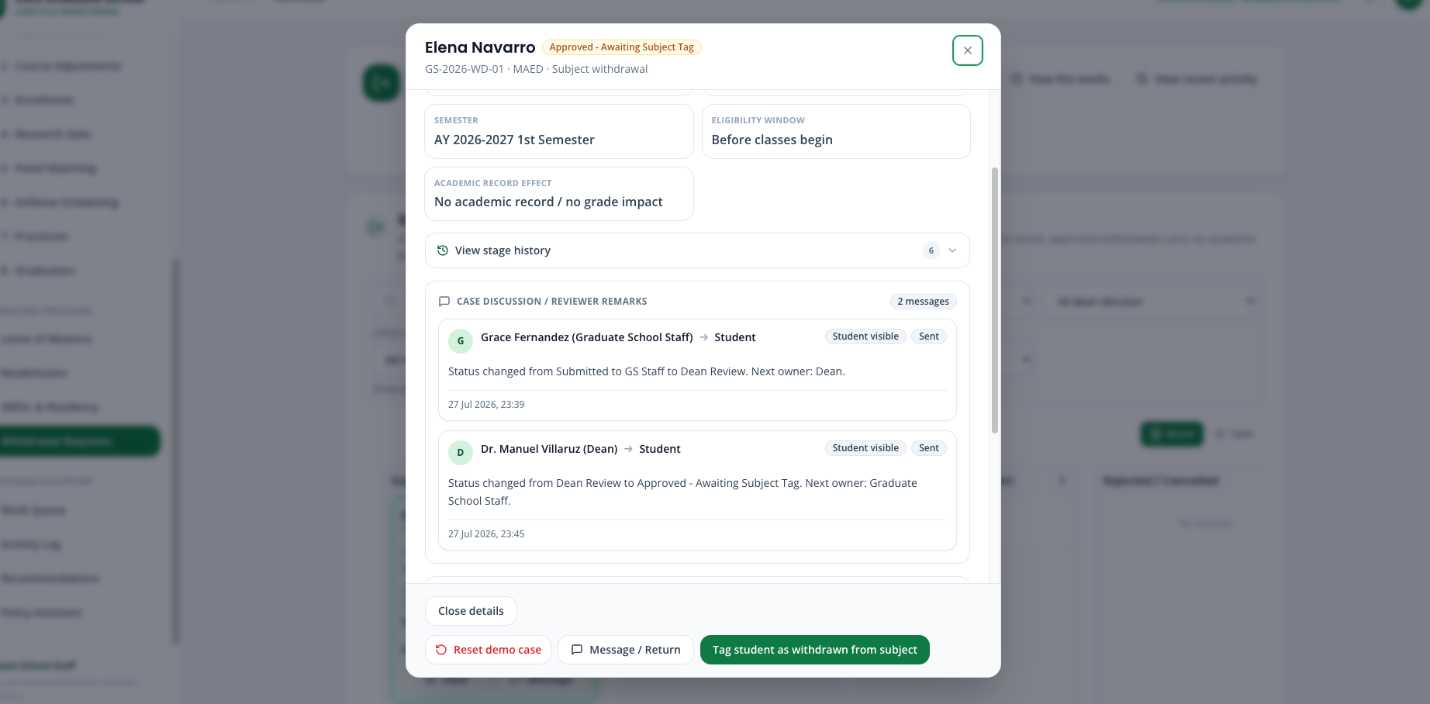
Step 17. Select Tag student as withdrawn from subject.
Step 18. Confirm that only MAED-MAJ1 changes to Withdrawn.
Step 19. Open 3 · Enrollment and locate Elena in Official Offered Subjects.
Step 20. Confirm that MAED-MAJ1 displays Withdrawn, while Elena’s program standing remains Active and her other subjects remain unchanged.
Step 21. Confirm that the selected subject has No Grade, no grade value, no academic penalty, and no adverse academic-record result.
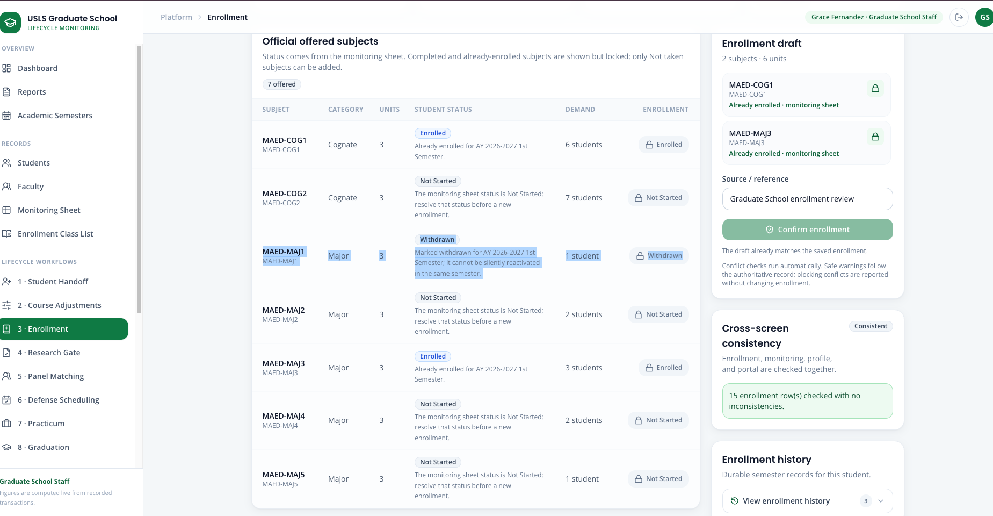
Step 22. Return to the Withdrawal page. The approved-withdrawals Excel popup should appear after the subject is tagged.
Step 23. Confirm that Elena is listed under Tagged withdrawn students.
Step 24. Select Elena or use Select all, then select Download Excel list.
Step 25. Confirm that the downloaded workbook contains Elena, the selected subject, semester, Dean decision, deadline, and the statement No academic record / no grade impact.
Step 26. Verify the small post-export popup. It must state that the portal did not send an email and that GS Staff must email the downloaded Excel workbook to the Registrar and wait for acknowledgement.
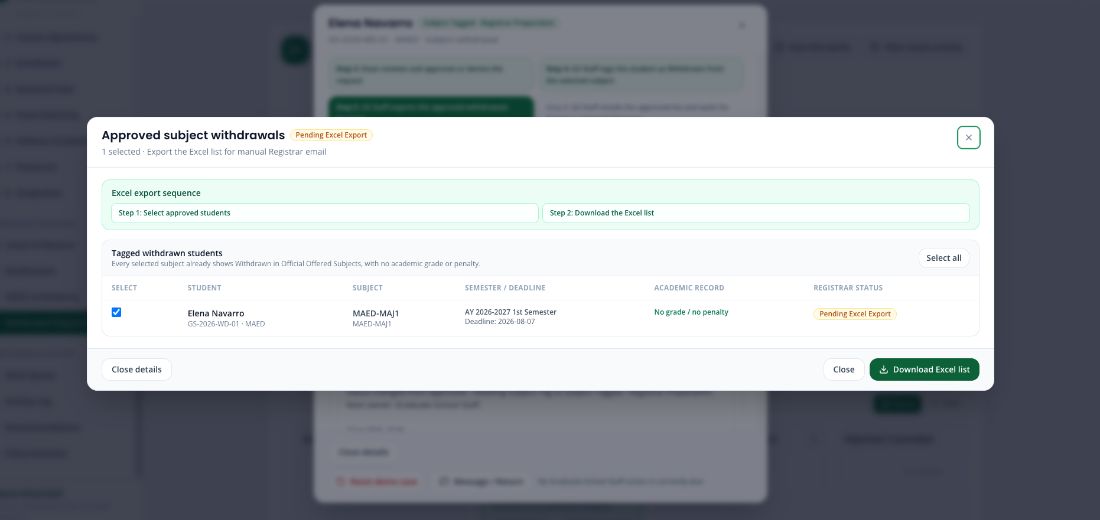
Step 27. Confirm that the case remains Exported — Ready to Send. The portal must not falsely record an external email or Registrar acknowledgement.
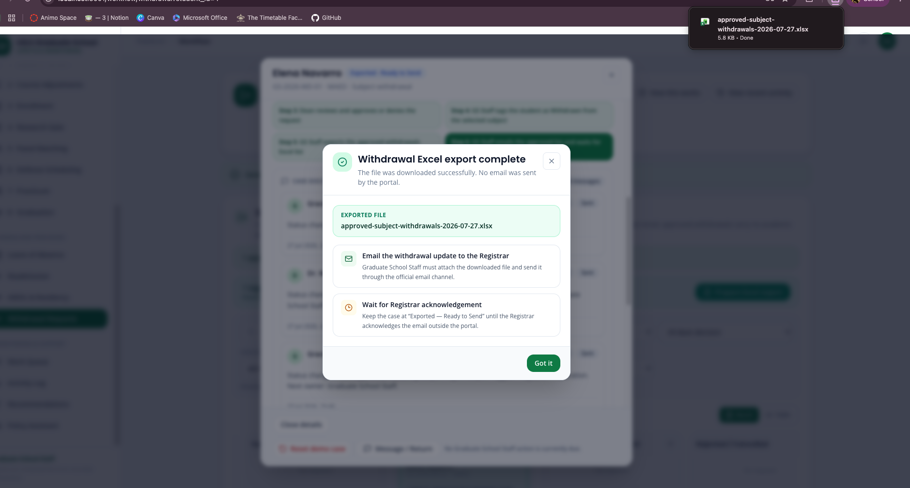
Step 28. Sign back in as Elena. Confirm the following student workflow results:
- Step 3 shows Dean approval.
- Step 4 states that MAED-MAJ1 was tagged as Withdrawn.
- Step 5 states that the withdrawal was included in the Excel list.
- Step 6 states that GS Staff must manually email the file and wait for acknowledgement.
- Elena remains Active in the graduate program.

Part B - Unusual case: Dean denies withdrawal
Step 1. Reset Joshua Lim’s Withdrawal demo.
Step 2. Sign in as Joshua and open Subject Withdrawal.
Step 3. Select MAED-MAJ2 and confirm the displayed Eligible until deadline.
Step 4. Enter Joshua’s reason and select Send withdrawal request. No PDF is required.
Step 5. Sign in as GS Staff, open Joshua’s request, and select Record & forward to Dean.
Step 6. Sign in as the Dean and open Withdrawal Requests.
Step 7. Open Joshua’s request and review the selected subject, submission date, eligibility window, and reason.
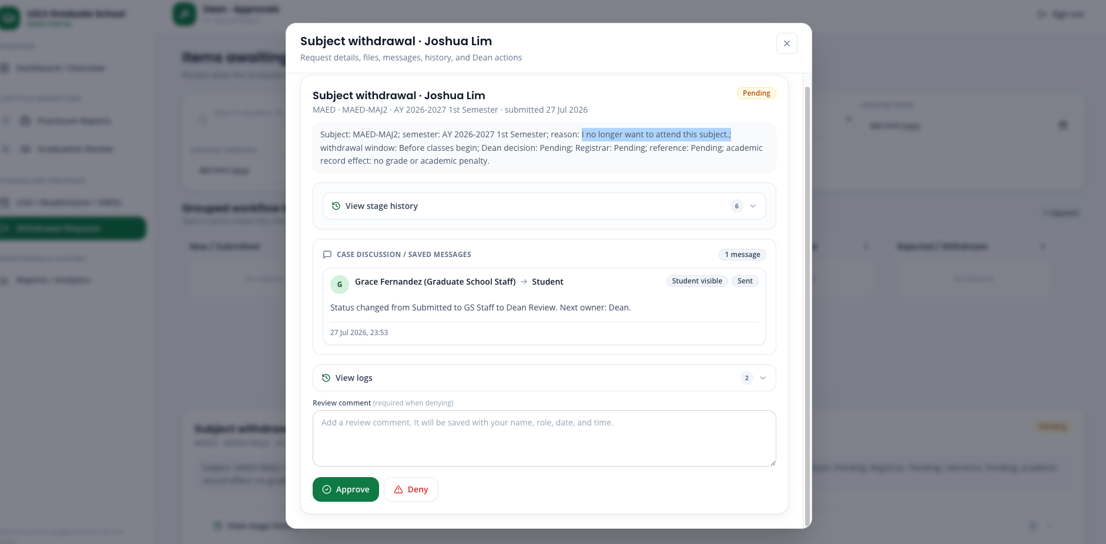
Step 8. Enter the required denial reason: The stated reason does not meet the approved grounds for subject withdrawal.
Step 9. Select Deny.
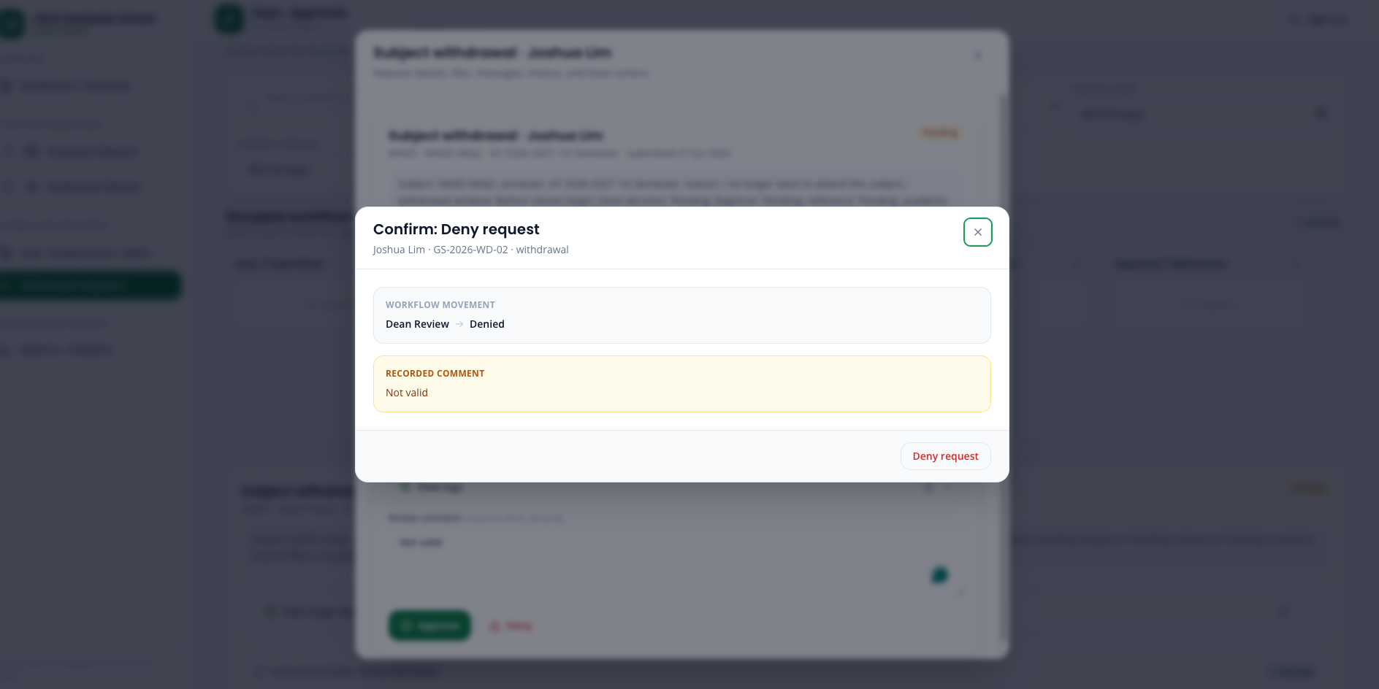
Step 10. Confirm that Joshua’s request moves to Denied.
Step 11. Confirm that no Tag student as withdrawn from subject button becomes available.
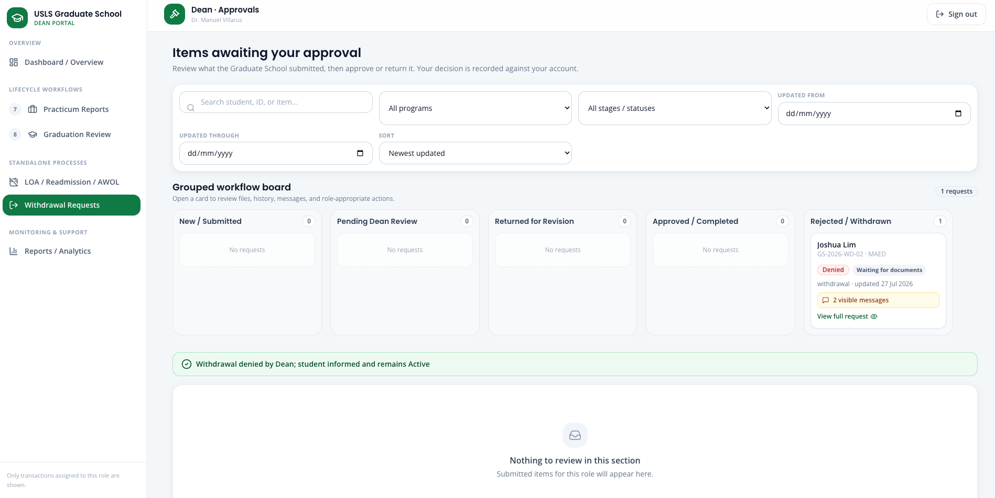
Step 12. Confirm that Joshua is not included in the approved-withdrawals Excel popup.
Step 13. Open 3 · Enrollment and verify that MAED-MAJ2 remains Enrolled.
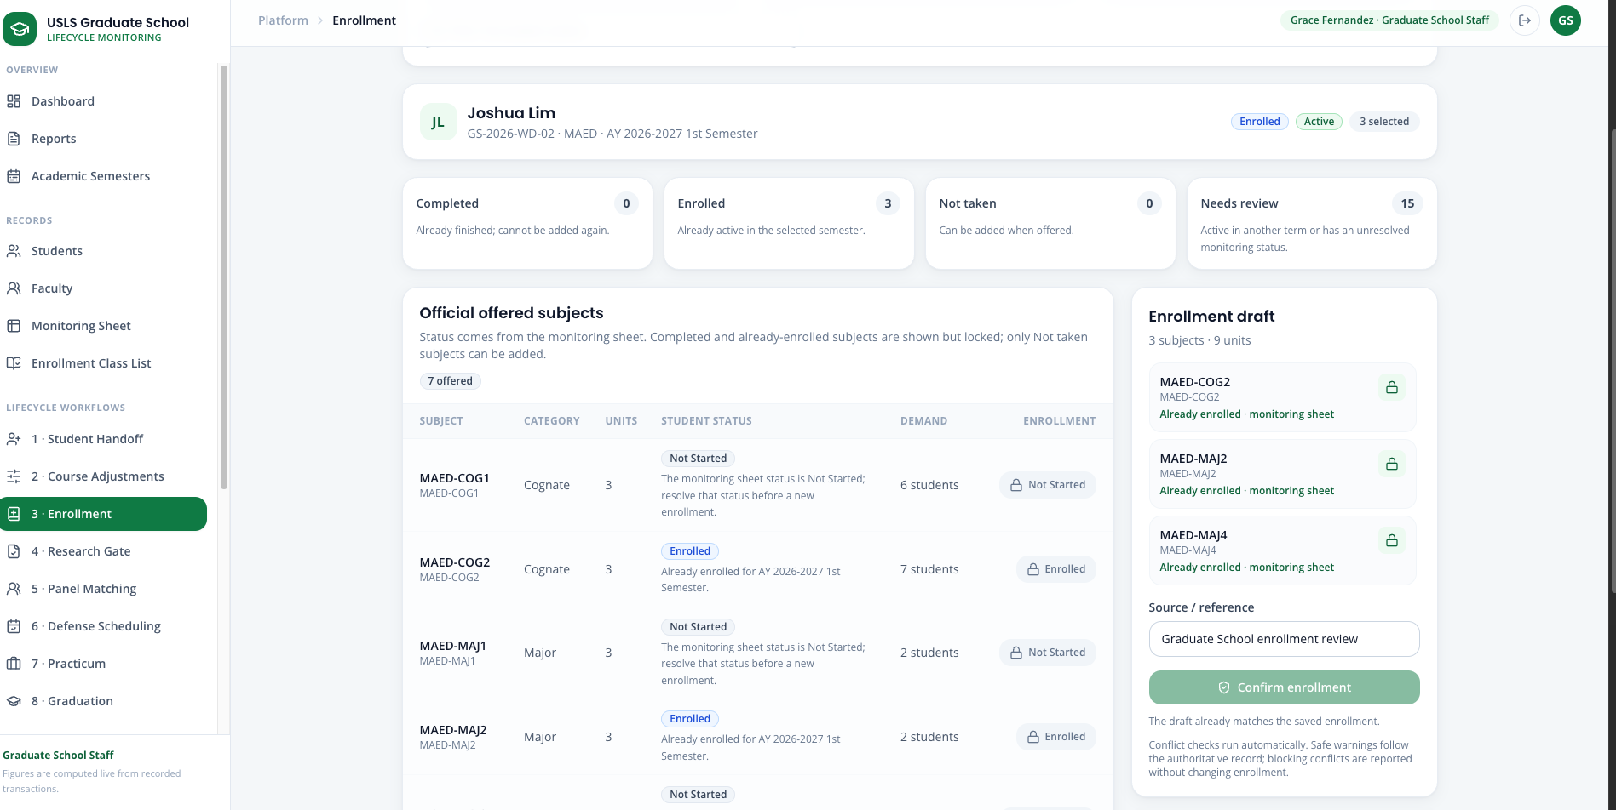
Step 14. Confirm that Joshua’s program standing remains Active and that no subject, grade, or unrelated enrollment was changed.
Step 15. Sign back in as Joshua.
Step 16. Confirm that Withdrawal Step 3 displays the denial and states that the selected subject remains enrolled.
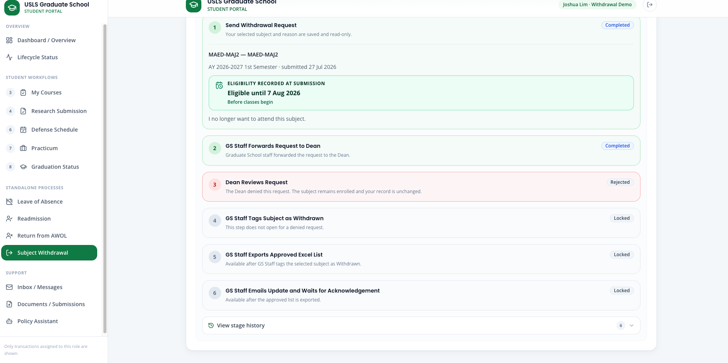
Step 17. Open the Request Center and confirm that the Dean’s reason is visible in the discussion.
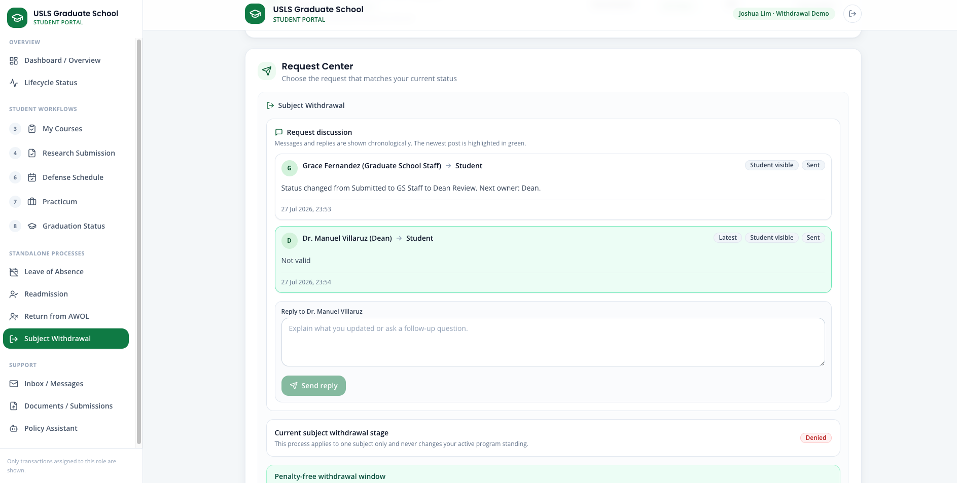

Scenario 6 — Research Gate, Panel Matching, and Defense Scheduling
Story:
Miguel Yu is ready to submit his Title Defense requirements. The portal checks his required research submissions, helps staff assemble a qualified panel, and finds a common defense schedule.
Accounts used:
Field | Value / Instruction
Student | student@usls.edu.ph (Miguel Yu)
Coordinator / Staff | research@usls.edu.ph or staff@usls.edu.ph
Steps:
Step 1. As the student, submit the required research forms, then open 4 · Research Gate (as staff) to confirm the submissions are received and marked as submitted versus verified.
Step 2. Open 5 · Panel Matching. Review the recommended panel shortlist, adjust it if needed, and finalize the panel. An adviser designation is required before adviser-related actions.
Step 3. Open 6 · Defense Scheduling to find and confirm the earliest common available slot for the panel.
Note: A submitted file is recorded as received, not as academically validated content. The panel recommendation is a suggestion that an authorized person accepts, modifies, or replaces.
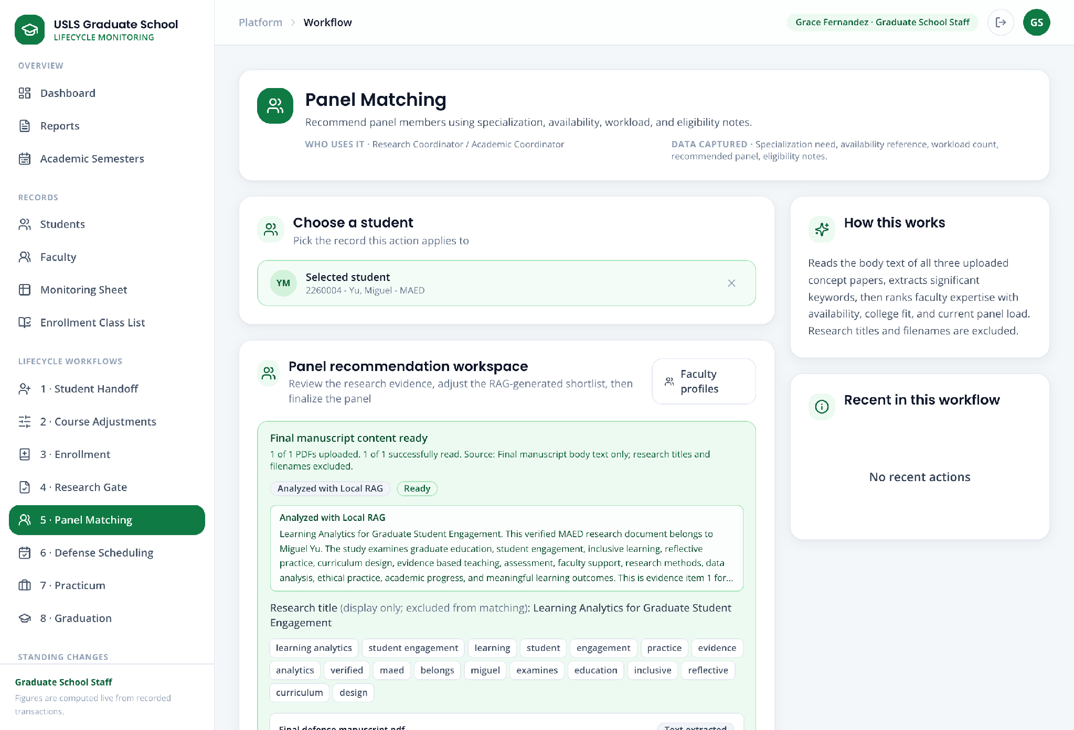
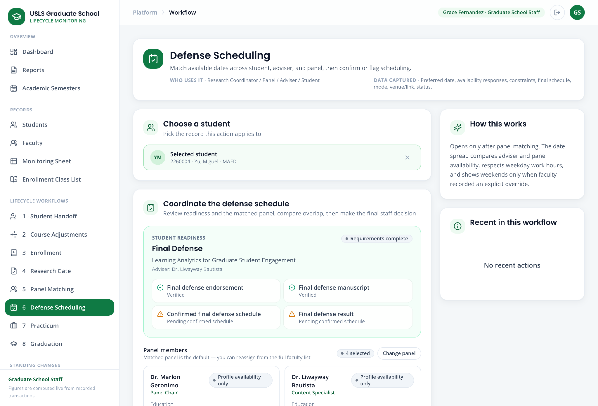
Screenshot — Panel Matching with the recommended shortlist, and Defense Scheduling with the proposed common slot.

Scenario 7 - Title Defense
Story:
Andrea Mae Villanueva is ready to begin the Title Defense stage. She submits her completed Form 1 Application and three concept papers. Graduate School Staff checks the submitted requirements, the Academic Coordinator endorses Form 1, and GS Staff selects and finalizes the four-person defense panel.
Accounts used:
Role | Account
Standard-case student | andrea.mae.villanueva@student.usls.edu.ph
Graduate School Staff | staff@usls.edu.ph
Academic Coordinator | academic@usls.edu.ph

Part A - Student submission
Step 1. Sign in as Andrea Mae Villanueva.
Step 2. Open Research Submission.
Step 3. Confirm that Andrea’s current research stage is Title Defense.
Step 4. Upload the completed Form 1 Application.
Step 5. Upload all three concept papers.
Step 6. Review the uploaded documents.
Step 7. Select Submit Title Defense for Review.
Step 8. Confirm that the submission status changes to Pending Review.
Step 9. Sign out.
Screenshot — The student Research Submission screen showing the Form 1 Application, three concept papers, and Pending Review status.
Part B - GS Staff requirement verification
Step 10. Sign in as GS Staff.
Step 11. Open 5 · Research Gate.
Step 12. Search for and open Andrea Mae Villanueva’s record.
Step 13. Review the submitted Form 1 Application and three concept papers.
Step 14. Confirm that the files uploaded by Andrea are visible in the staff view.
Step 15. Select Verify Submitted Requirements.
Step 16. Confirm that the submitted requirements are marked as verified.
Step 17. Sign out.
Screenshot — Andrea’s Research Gate record showing the uploaded documents, verified requirements, and pending Form 1 endorsement.
Part C - Academic Coordinator Form 1 endorsement
Step 18. Sign in as the Academic Coordinator.
Step 19. Open 5 · Research Gate.
Step 20. Select Form 1 Endorsements.
Step 21. Open Andrea Mae Villanueva’s Form 1 Application.
Step 22. Review the Form 1 details and submitted concept papers.
Step 23. Draw the Academic Coordinator’s signature in the signature area.
Step 24. Select Finalize Signature.
Step 25. Confirm that Form 1 is marked as signed and endorsed.
Step 26. Return to 5 · Research Gate.
Step 27. Confirm that Andrea’s Form 1 endorsement status has been updated.
Step 28. Sign out.
Screenshot — The Form 1 endorsement screen showing the signature area.
Screenshot — Andrea’s Research Gate record after the Academic Coordinator endorsement has been completed.
Part D - Panel matching and final selection
Step 29. Sign in as GS Staff.
Step 30. Open 6 · Panel Matching.
Step 31. Select Andrea Mae Villanueva.
Step 32. Review the RAG/AI-generated faculty recommendations.
Step 33. Review each faculty member’s match score, specialization, matching keywords, and availability.
Step 34. Search for other faculty members if needed.
Step 35. Select four panelists.
Step 36. Assign one selected faculty member as the Panel Chair or Panel Lead.
Step 37. Select Finalize Selected Panel.
Step 38. Confirm that the finalized panel appears in Andrea’s record.
Step 39. Sign out.
Screenshot — The Panel Matching screen showing ranked faculty recommendations and match scores.
Screenshot — Andrea’s finalized panel showing the four selected panelists and assigned Panel Chair or Panel Lead.

Scenario 8 — Defense Scheduling and Rescheduling
Story:
After Andrea’s research requirements and panel assignments are completed, GS Staff reviews the shared availability of the selected panelists and finalizes the defense schedule. After the defense, only the assigned Panel Chair or Panel Lead can submit the official verdict.
Accounts used:
Role | Account
Student | andrea.mae.villanueva@student.usls.edu.ph
Academic Coordinator | academic@usls.edu.ph
Panel Chair | Depends on chosen panel chair for defense
Part A - Set the defense schedule
Step 1. Sign in as GS Staff.
Step 2. Open 7 · Defense Scheduling.
Step 3. Select Andrea Mae Villanueva.
Step 4. Confirm Andrea’s current research stage and readiness status.
Step 5. Confirm that the required Research Gate documents have been completed and verified.
Step 6. Review the four finalized panelists.
Step 7. Review their availability under Best Shared Options.
Step 8. Select the most suitable common schedule.
Step 9. Review the selected date and time under Final Schedule.
Step 10. Adjust the date, time, venue, or meeting details if necessary.
Step 11. Select Set Defense Schedule.
Step 12. Confirm that Andrea’s defense status changes to Scheduled.
Step 13. Sign out.
Screenshot — The Defense Scheduling screen showing Andrea’s selected panelists and their availability.
Screenshot — The Best Shared Options section showing common available schedules.
Screenshot — The Final Schedule section before confirmation.
Screenshot — Andrea’s finalized defense schedule showing the date, time, panelists, and Scheduled status.

Part B - Rescheduling
Step 14. If the schedule needs to be changed, sign in as GS Staff.
Step 15. Open 7 · Defense Scheduling.
Step 16. Reopen Andrea Mae Villanueva’s defense record.
Step 17. Select the available Edit Schedule or Reschedule action.
Step 18. Review the panelists’ updated availability.
Step 19. Select a new shared schedule or manually adjust the date and time.
Step 20. Save the updated schedule.
Step 21. Confirm that the schedule status changes to Rescheduled.
Step 22. Sign out.
Screenshot — The defense rescheduling screen showing the previous schedule and updated schedule.
Part C - Panel Chair or Panel Lead submits the verdict
Step 23. Sign in using Andrea’s assigned Panel Chair or Panel Lead account.
Step 24. Open Advisees & Research.
Step 25. Go to Panel Papers and Defense Verdicts.
Step 26. Open Andrea Mae Villanueva’s defense record.
Step 27. Review Andrea’s research documents, defense stage, and schedule.
Step 28. Select the appropriate verdict result.
Available verdicts may include:
Passed
Failed
Step 29. Enter remarks or required revisions, if applicable.
Step 30. Select Submit Final Verdict.
Step 31. Confirm that the verdict has been recorded.
Step 32. Sign out.
Screenshot — The Panel Papers and Defense Verdicts screen showing Andrea’s assigned defense.
Screenshot — The verdict form showing the selected result and remarks.
Screenshot — Andrea’s defense record after the verdict has been submitted.
Part D - Unusual case: Student fails the defense
Story:
The assigned Panel Chair determines that Andrea did not pass the defense. The Panel Chair submits a Failed verdict, and Andrea must upload the required documents again for the same research stage.
Step 33. Sign in using Andrea’s assigned Panel Chair or Panel Lead account.
Step 34. Open Advisees & Research.
Step 35. Go to Panel Papers and Defense Verdicts.
Step 36. Open Andrea Mae Villanueva’s defense record.
Step 37. Select Failed as the verdict result.
Step 38. Enter the following sample remark:
The student must revise and resubmit the required documents before another defense may be scheduled.
Step 39. Select Submit Final Verdict.
Step 40. Confirm that Andrea’s defense status changes to Failed.
Step 41. Confirm that Andrea’s research submission status changes to Resubmission Required.
Step 42. Sign out.
Screenshot —The Panel Chair verdict form showing Failed as the selected result.
Screenshot — Andrea’s defense record showing the Failed verdict and Resubmission Required status.
Student Resubmission
Step 43. Sign in as Andrea Mae Villanueva.
Step 44. Open Research Submission.
Step 45. Confirm that Andrea remains in the same research stage.
Step 46. Confirm that the status shows Resubmission Required.
Step 47. Upload the revised or replacement documents required for the current stage.
For Title Defense, resubmit:
Form 1 Application
Concept Paper 1
Concept Paper 2
Concept Paper 3

For Proposal Defense, resubmit:
Proposal Manuscript
Research Protocol Form 5.2 Ethics Clearance
Proposal Defense Endorsement
Statistical Consultation Form or Qualitative Exemption, Form 4.1
Proposal Manuscript Endorsement

For Final Defense, resubmit:
Final Defense Endorsement
Final Defense Manuscript
Step 48. Review the newly uploaded documents.
Step 49. Select Submit for Review again.
Step 50. Confirm that the submission status changes from Resubmission Required to Pending Review.
Step 51. Sign out.
Screenshot — The student Research Submission screen showing the Failed verdict notice and Resubmission Required status.
Screenshot — The revised documents after resubmission and the new Pending Review status.

Scenario 9 — Proposal Defense
Story:
After completing the Title Defense stage, Andrea submits the requirements for Proposal Defense. Her assigned Faculty Adviser reviews and signs the required papers. The Research Coordinator records the ethics clearance, while GS Staff verifies the complete submission and finalizes the panel before scheduling the defense.
Accounts used:
Role | Account
Student | andrea.mae.villanueva@student.usls.edu.ph
Faculty Adviser | Use Andrea’s assigned adviser account
Research Coordinator | research@gs.local
Graduate School Staff | staff@gs.local

Part A - Student submission
Step 1. Sign in as Andrea Mae Villanueva.
Step 2. Open Research Submission.
Step 3. Confirm that Andrea’s current stage is Proposal Defense.
Step 4. Upload the Proposal Manuscript.
Step 5. Upload Research Protocol Form 5.2 Ethics Clearance.
Step 6. Upload the Proposal Defense Endorsement.
Step 7. Upload the Statistical Consultation Form or Qualitative Exemption, Form 4.1.
Step 8. Upload the Proposal Manuscript Endorsement.
Step 9. Review all submitted documents.
Step 10. Select Submit Proposal Defense for Review.
Step 11. Confirm that the submission is pending adviser signatures and staff verification.
Step 12. Sign out.
Screenshot — The Proposal Defense submission screen showing all required documents.
Part B - Faculty Adviser signatures
Step 13. Sign in using Andrea’s assigned Faculty Adviser account.
Step 14. Open Advisees & Research.
Step 15. Go to Adviser Paper Signatures.
Step 16. Select Andrea Mae Villanueva.
Step 17. Open and review the Proposal Manuscript.
Step 18. Draw the adviser’s signature.
Step 19. Select Finalize Signature.
Step 20. Select Sign This Document.
Step 21. Open and review the Endorsement for Proposal Defense.
Step 22. Draw the adviser’s signature.
Step 23. Select Finalize Signature.
Step 24. Select Sign This Document.
Step 25. Open and review the Endorsement for Proposal Manuscript.
Step 26. Draw the adviser’s signature.
Step 27. Select Finalize Signature.
Step 28. Select Sign This Document.
Step 29. Confirm that all three documents are marked as adviser-signed.
Step 30. Sign out.
Screenshot — The Adviser Paper Signatures screen showing Andrea’s documents awaiting signature.
Screenshot — The signature area while signing one of Andrea’s papers.
Screenshot — Andrea’s documents after all required adviser signatures have been completed.
Part C - Research Coordinator ethics clearance
Step 31. Sign in as the Research Coordinator.
Step 32. Open 5 · Research Gate.
Step 33. Select Andrea Mae Villanueva.
Step 34. Review the submitted Form 5.2 Ethics Clearance.
Step 35. Select Record Clearance.
Step 36. Select the appropriate clearance status.
Step 37. Select Record Ethics Clearance.
Step 38. Confirm that Andrea’s ethics clearance status has been updated.
Step 39. Sign out.
Screenshot — The Research Coordinator ethics clearance screen showing Form 5.2 and the clearance status options.
Screenshot — Andrea’s Research Gate record showing the recorded ethics clearance.
Part D - GS Staff verification and panel matching
Step 40. Sign in as GS Staff.
Step 41. Open 5 · Research Gate.
Step 42. Open Andrea Mae Villanueva’s record.
Step 43. Review all submitted documents.
Step 44. Confirm that the adviser signatures and ethics clearance have been completed.
Step 45. Select Verify Submitted Requirements.
Step 46. Confirm that the Proposal Defense requirements are marked as complete.
Step 47. Open 6 · Panel Matching.
Step 48. Select Andrea Mae Villanueva.
Step 49. Review the AI-generated panel recommendations, match scores, specializations, and availability.
Step 50. Select four panelists.
Step 51. Assign one selected faculty member as Panel Chair or Panel Lead.
Step 52. Select Finalize Selected Panel.
Step 53. Confirm that the panel is connected to Andrea’s Proposal Defense record.
Step 54. Continue with the Defense Scheduling and Rescheduling process in Section 10.
Screenshot — Andrea’s Research Gate record showing completed Proposal Defense requirements.
Screenshot — The Panel Matching screen showing recommendations based on Andrea’s Proposal Manuscript.
Screenshot — Andrea’s finalized Proposal Defense panel.
Note: If Andrea fails the Proposal Defense, follow the unusual case in Scenario X. Andrea must resubmit the Proposal Defense documents and repeat the same review process.

Scenario 10 — Final Defense
Story:
Andrea submits her Final Defense requirements. Her Faculty Adviser reviews and signs the Final Defense Endorsement and Final Manuscript. GS Staff verifies the documents, finalizes the panel, and schedules the defense. After Andrea receives a passing verdict, she submits the required post-defense documents so her research status can be marked complete.
Accounts used:
Role | Account
Student | andrea.mae.villanueva@student.usls.edu.ph
Faculty Adviser | Use Andrea’s assigned adviser account.
Graduate School Staff | staff@usls.edu.ph
Panel Chair | Depends on chosen panel chair for defense

Part A - Student Final Defense submission
Step 1. Sign in as Andrea Mae Villanueva.
Step 2. Open Research Submission.
Step 3. Confirm that Andrea’s current stage is Final Defense.
Step 4. Upload the Final Defense Endorsement.
Step 5. Upload the Final Defense Manuscript.
Step 6. Review the uploaded documents.
Step 7. Select Submit Final Defense for Review.
Step 8. Confirm that the submission is pending adviser signatures and staff verification.
Step 9. Sign out.
Screenshot — The Final Defense submission screen showing the Final Defense Endorsement and Final Manuscript.

Scenario 11 — Practicum
Story:
Andrea Villanueva, a Psychology student, completes the standard practicum process. Paolo Ramirez, an MSGC student, demonstrates the unusual case by initially submitting only 120 of the required 200 hours. The platform prevents completion, requests additional evidence, preserves the original files, and allows Paolo to submit a new certificate PDF and updated hours.
The Practicum workflow is available only to Psychology and Master of Science in Guidance and Counseling students. Students from all other programs are excluded from the Practicum page and cannot submit a practicum request.
Accounts used:
Role | Account
Standard-case student | practicum.andrea@usls.edu.ph
Unusual-case student | practicum.paolo@usls.edu.ph
Graduate School Staff | staff@usls.edu.ph
Academic Coordinator | academic@usls.edu.ph
Dean | dean@usls.edu.ph
Part A - Standard practicum completion
Step 1. On the login page, open Student workflow demos → 7 · Practicum and reset Andrea Villanueva’s demo if it contains previous activity.
Step 2. Sign in as Andrea. Open 7 · Practicum.
Step 3. Confirm that the page displays “Psychology and MSGC students only” and identifies Andrea’s MAPSY program as being within the permitted scope.
Step 4. Review Step 1 · Eligibility Check / Pre-Practicum Requirements. The system automatically checks Andrea’s program, completed units, and preceding research milestones.
Step 5. In Step 2 · MOA Submission, enter the practicum site and supervisor, upload the signed MOA PDF, add the optional remarks, and select Submit MOA stage.
Andrea’s standard submission
Practicum site: USLS Partner Psychological Services Center
Supervisor: Dr. Maria Reyes
Required hours: 200
Completed hours: 200
MOA file: Andrea_Villanueva_Practicum_MOA.pdf
Completion file: Andrea_Villanueva_Completion_Certificates.pdf
Remarks: All required practicum hours and completion documents are attached.
Step 6. Sign in as GS Staff and open 7 · Practicum. Open Andrea’s case and confirm that the MOA status is MOA Submitted.
Step 7. Select Forward to Academic Coordinator. Add a comment such as: Please review Andrea’s signed practicum MOA.
Step 8. Sign in as the Academic Coordinator and open 7 · Practicum. Open Andrea’s case and select Mark practicum in progress.
Step 9. Sign back in as Andrea. In Step 3 · Practicum Document Submission, enter 200 completed hours and upload the completion certificates/forms PDF.
Step 10. Select Submit completion stage. The documents are routed to GS Staff.
Step 11. Sign in as GS Staff, open Andrea’s case, and select Forward documents to Academic Coordinator.
Step 12. Sign in as the Academic Coordinator. Confirm that the case shows 200/200 hours and select Verify completion.
Step 13. Open the completed case again and select Send status report to Dean.
Step 14. Sign in as the Dean and open 7 · Practicum from the Dean workflow navigation.
Step 15. Review the status report, submitted files, hours, and workflow timeline. Select Mark reviewed.
Step 16. Confirm that Andrea’s final practicum status is Dean Reviewed and that the student’s Step 5 shows final verification as complete.
Screenshot — The Graduation screen with the eligibility check, and the Dean-approved endorsement list ready to export.
Part B - Unusual case: insufficient practicum hours
Step 1. Return to the login page and reset Paolo Ramirez’s Practicum demo.
Step 2. Sign in as Paolo and open 7 · Practicum. Confirm that his MSGC program is identified as eligible for Practicum.
Step 3. Complete the MOA submission using Paolo’s sample information and upload his signed MOA PDF.
Paolo’s unusual submission
Practicum site: Guidance and Counseling Partner Center
Supervisor: Ms. Angela Cruz
Required hours: 200
Initial completed hours: 120
Initial completion file: Paolo_Ramirez_Initial_Practicum_Certificates.pdf
Additional file: Paolo_Ramirez_Additional_Practicum_Certificate.pdf
Initial remarks: Initial certificates covering 120 completed practicum hours.
Resubmission remarks: The additional certificate covers the remaining 80 practicum hours.
Step 4. Sign in as GS Staff and select Forward to Academic Coordinator.
Step 5. Sign in as the Academic Coordinator and select Mark practicum in progress.
Step 6. Sign back in as Paolo. Enter only 120 completed hours instead of the required 200, upload the initial completion-certificate PDF, and select Submit completion stage.
Step 7. Confirm that the platform records the case as Hours Incomplete. It must not allow the practicum to be marked complete.
Step 8. Sign in as GS Staff, open Paolo’s case, and select Forward documents to Academic Coordinator.
Step 9. Sign in as the Academic Coordinator. Open Paolo’s case and confirm that it displays 120/200 hours.
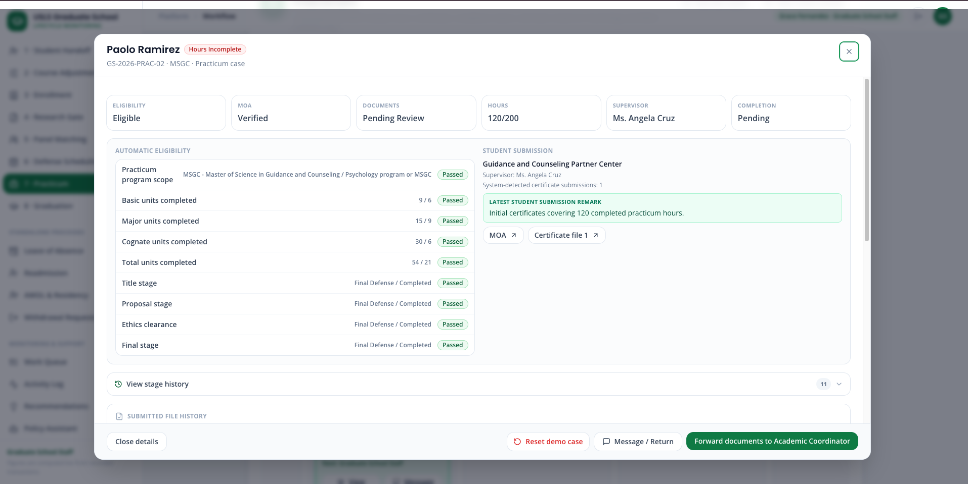
Step 10. Select Request additional certificates. Enter the required reason: Only 120 of the required 200 practicum hours are documented. Upload a new certificate covering the remaining hours.
Step 11. Confirm that Paolo’s case moves to Additional Certificates Requested and is returned to the student.
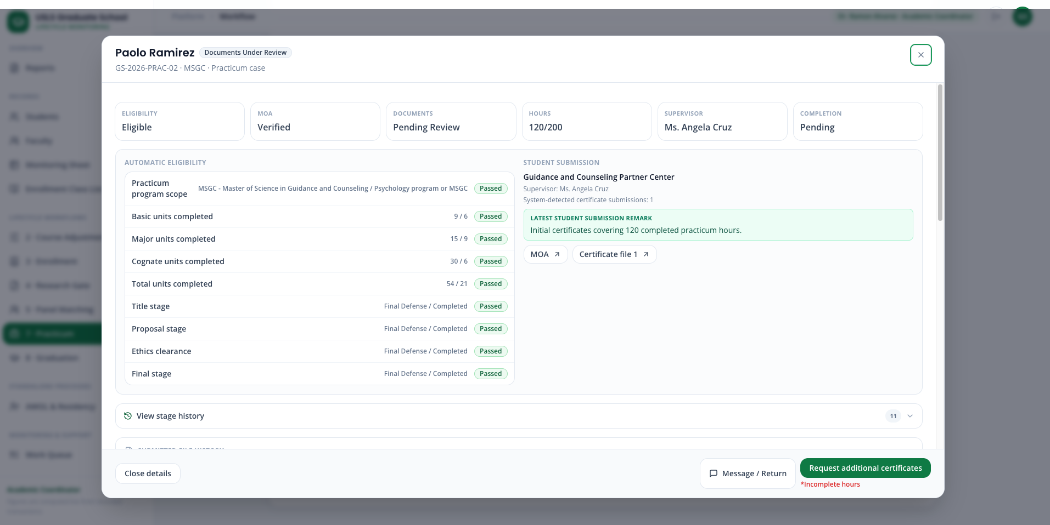
Step 12. Sign back in as Paolo. Open the Request Center and confirm that the newest staff message is highlighted in green within the white discussion-style message area.
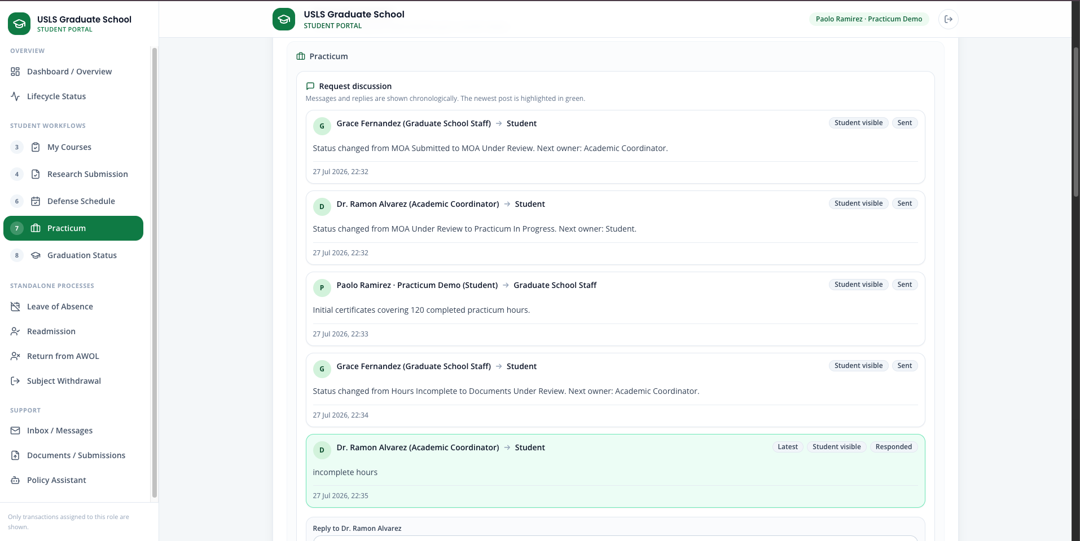
Step 13. Return to Practicum Step 3. Confirm that the earlier PDF remains visible in the file history but cannot be reused as the new response.
Step 14. Enter 200 completed hours and upload Paolo_Ramirez_Additional_Practicum_Certificate.pdf.
Step 15. Add the resubmission remark and select Resubmit completion stage.
Step 16. Sign in as GS Staff and forward the updated documents to the Academic Coordinator.
Step 17. Sign in as the Academic Coordinator. Confirm that the platform now shows 200/200 hours and two submitted certificate files.
Step 18. Select Verify completion, followed by Send status report to Dean.
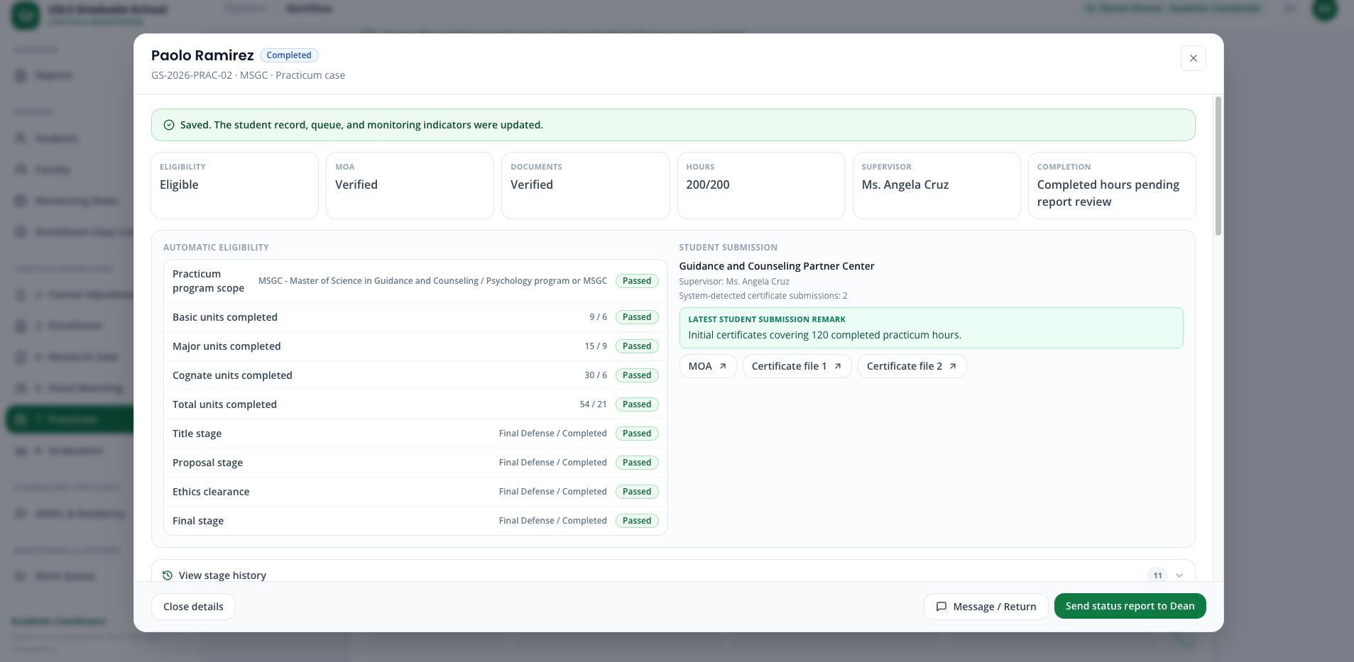
Step 19. Sign in as the Dean and select Mark reviewed.
Step 20. Confirm that Paolo’s final status is Dean Reviewed and that both the original and additional PDFs remain in the audit history.
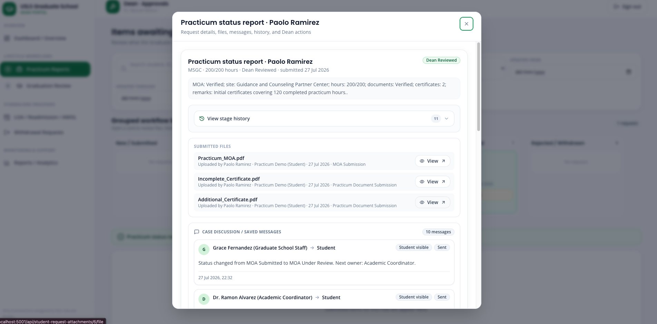

Scenario 12 — Graduation eligibility and endorsement
Story:
Bianca Santos demonstrates the standard graduation application and endorsement process. She is already academically eligible, so she appears in the staff Graduation page under Academically Eligible — Awaiting Student Application, but cannot be selected for a graduation batch until she submits her signed application PDF.
Carlo Mendoza demonstrates the unusual case. GS Staff finds incorrect information in his uploaded graduation application, returns it with a message, and requires a completely new PDF. Carlo sees the message, uploads a corrected document, and re-enters the normal graduation process.
Accounts used:
Role | Account
Standard-case student | practicum.andrea@usls.edu.ph
Unusual-case student | practicum.paolo@usls.edu.ph
Graduate School Staff | staff@usls.edu.ph
Academic Coordinator | academic@usls.edu.ph
Research Coordinator | research@usls.edu.ph
Dean | dean@usls.edu.ph
Suggested sample information:
Open graduation school year: AY 2026-2027
Bianca application: Bianca_Santos_Signed_Graduation_Application.pdf
Carlo incorrect application: Carlo_Mendoza_Incorrect_Graduation_Application.pdf
Carlo corrected application: Carlo_Mendoza_Corrected_Graduation_Application.pdf
Batch name: Batch 1 July 2026
GS Staff return message: The name and student number in the submitted application do not match the official student record. Upload a corrected signed application.
Optional Dean comment: Graduation candidates reviewed and approved for endorsement.
Important eligibility rule
Students appear on the Graduation page only when coursework, research stages, defense results, post-defense completion documents, and any required practicum are complete.
However, being academically eligible does not automatically allow batch selection:
- Before submitting an application, the student appears in Step 1 · Academically Eligible — Awaiting Student Application.
- After submitting the signed application PDF, the student moves to Step 2 · Application Submitted — Ready for Batch Creation.
- Only students in Step 2 can be selected for a graduation batch.
Part A - Standard graduation application and endorsement
Step 1. On the login page, open Student workflow demos → 8 · Graduation and reset Bianca Santos’s demo if it contains previous activity.
Step 2. Sign in as GS Staff and open 8 · Graduation.
Step 3. Confirm that Bianca appears in Step 1 · Academically Eligible — Awaiting Student Application. Confirm that no batch-selection checkbox is available for her yet.
Step 4. Sign in as Bianca and open 8 · Graduation.
Step 5. Confirm that Graduation Step 1 is available because all of Bianca’s preceding requirements are complete.
Step 6. Open the Graduation school year dropdown. Select AY 2026-2027. Confirm that other school years are gray and cannot be selected.
Step 7. Upload Bianca_Santos_Signed_Graduation_Application.pdf, add an optional remark, and select Submit graduation application.
Step 8. Sign in as GS Staff and return to 8 · Graduation.
Step 9. Confirm that Bianca moved to Step 2 · Application Submitted — Ready for Batch Creation.
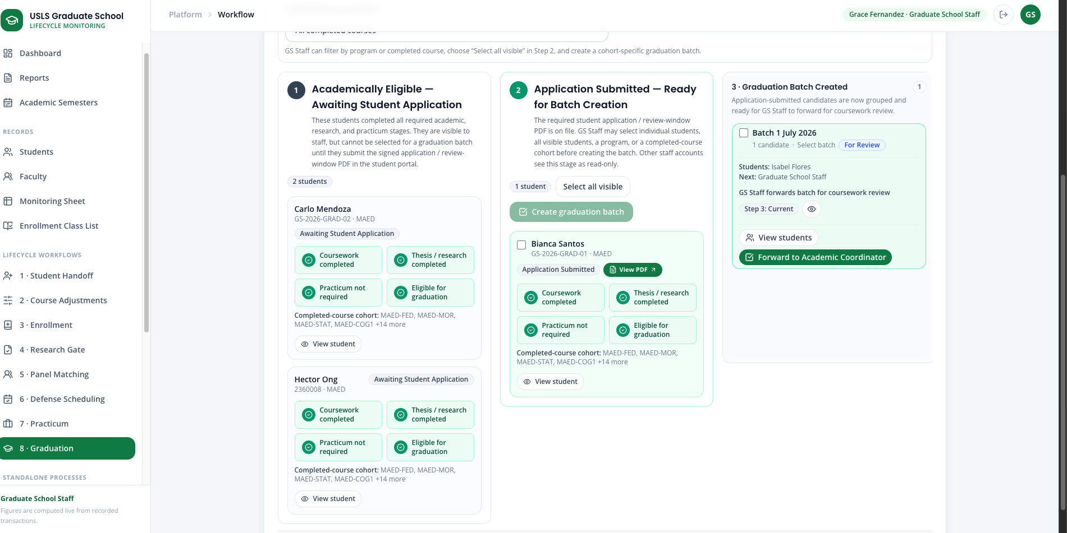
Step 10. Select the clickable View PDF button beside Bianca’s application-submitted status and verify the uploaded document.
Step 11. Select Bianca’s checkbox and select Create graduation batch.
Step 12. Enter the batch information for Batch 1 July 2026. Confirm that only the current AY 2026-2027 school year can be selected.
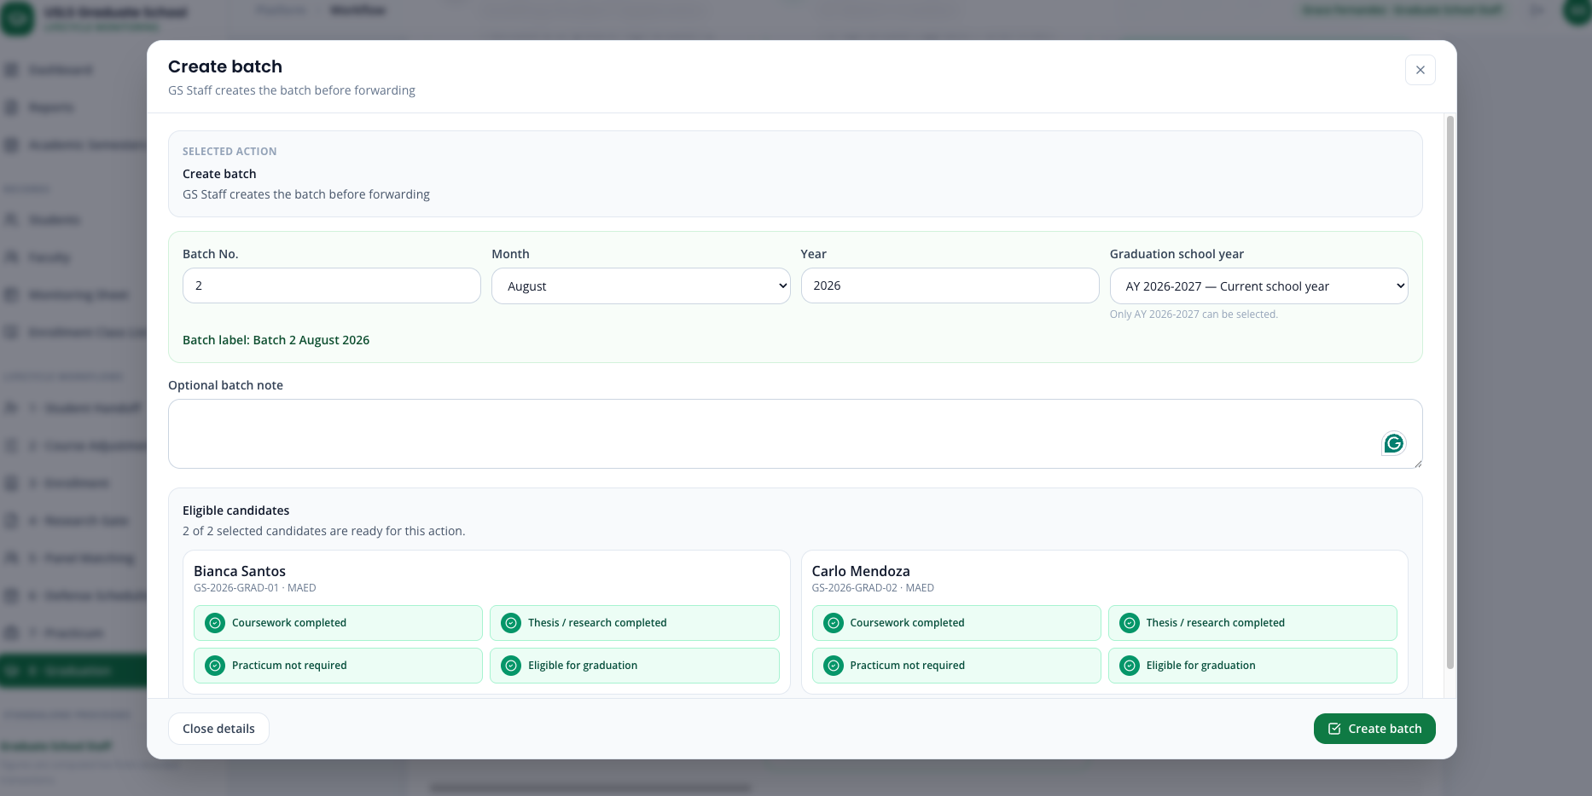
Step 13. Open the newly created batch in Step 3 · Graduation Batch Created and select Forward to Academic Coordinator.
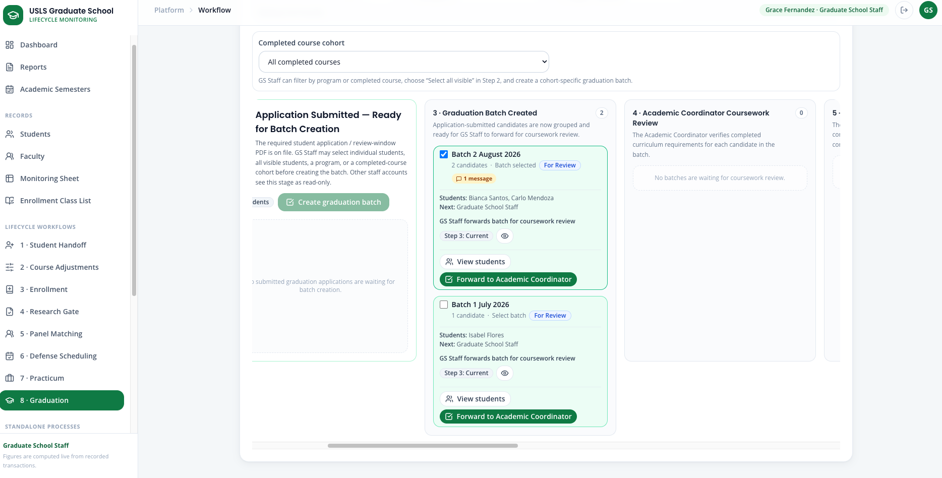
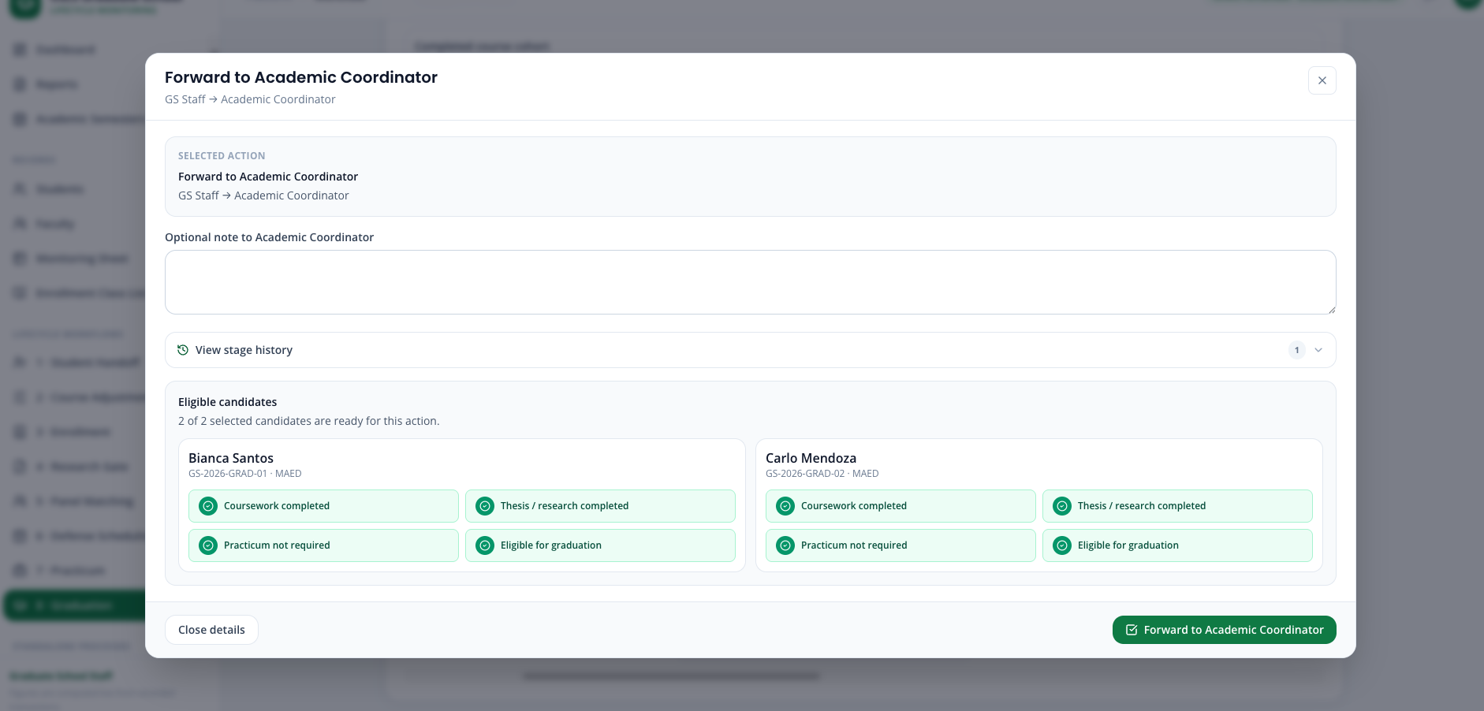
Step 14. Sign in as the Academic Coordinator and open 8 · Graduation.
Step 15. Open the batch in Step 4 · Academic Coordinator Coursework Review and select Check coursework completion.
Step 16. Confirm that Bianca’s completed curriculum is validated and that the batch moves to the Research Coordinator.
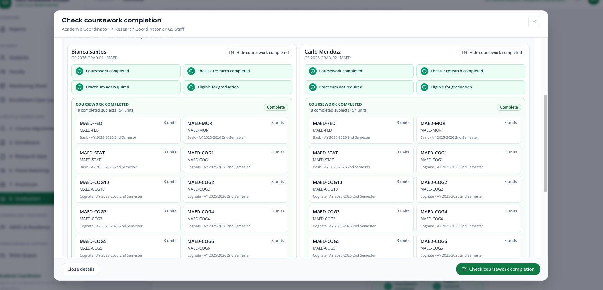
Step 17. Sign in as the Research Coordinator and open 8 · Graduation.
Step 18. Open the batch in Step 5 · Research and Practicum Validation and select Validate research completion requirements.
Step 19. Confirm that the research gates, panel assignments, defense schedules, passing results, completion evidence, and any required practicum are validated.
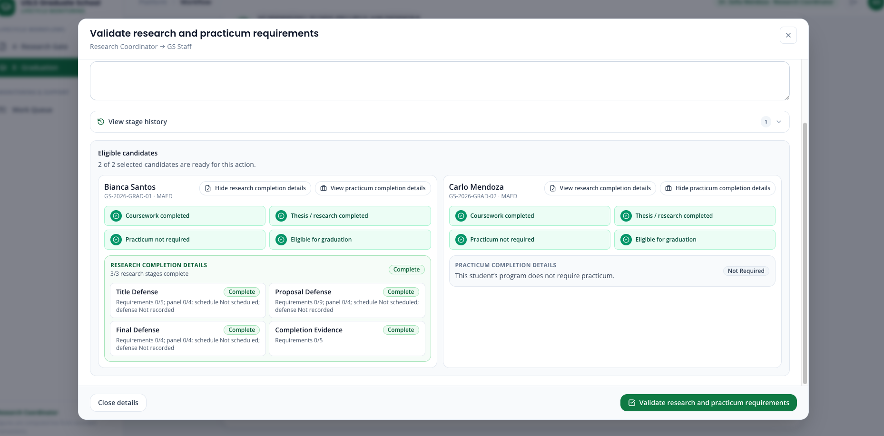
Step 20. Sign in as GS Staff. Open the batch in Step 6 · Endorsement Preparation or Revision and select Prepare endorsement list.
Step 21. Open the prepared batch again and select Send endorsement list to Dean.
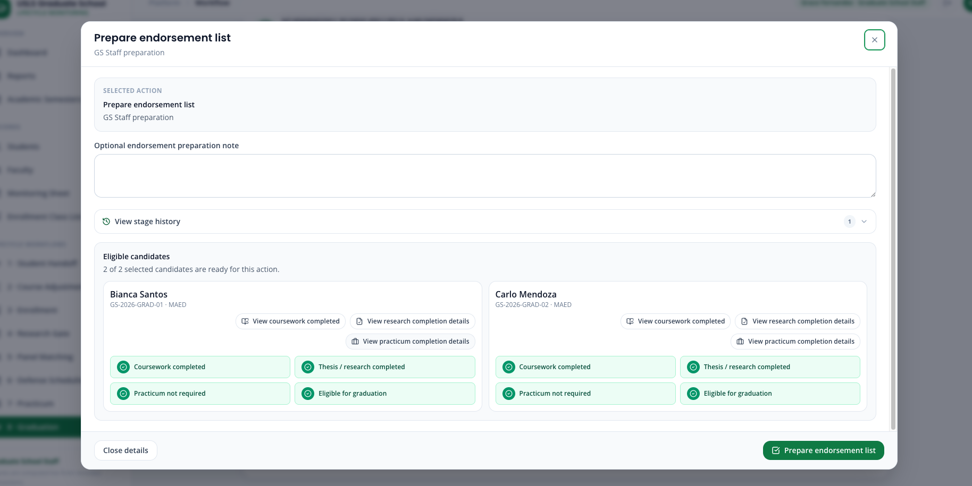
Step 22. Sign in as the Dean and open 8 · Graduation. Confirm that the Dean sees the same staged Kanban workflow and can inspect the students inside the batch.
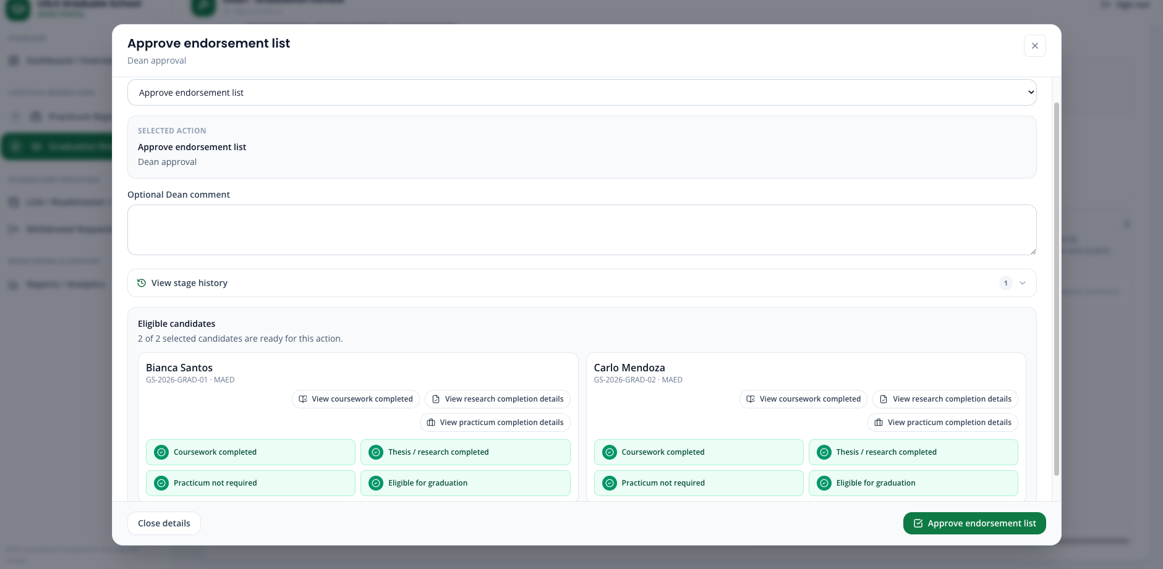
Step 23. Open the batch in Step 7 · Dean Review, review the candidate details, and select Approve and prepare for export.
Step 24. Confirm that the batch moves to Step 8 · Dean Approved and Ready for Export.
Step 25. Select Export approved list. Confirm that the endorsed graduation list downloads as a CSV file.
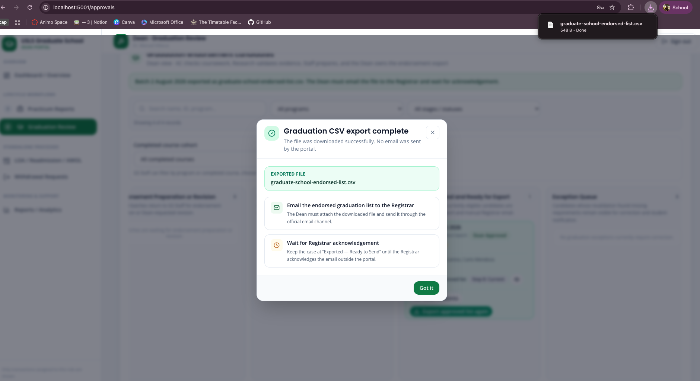
Step 26. Verify the small post-export popup. It must state that the portal did not send an email and that the Dean must email the downloaded CSV to the Registrar and wait for acknowledgement.
Step 27. Confirm that the portal status remains Exported — Ready to Send. It must not falsely claim that an external email or Registrar acknowledgement occurred.
Part B - Unusual case: incorrect graduation application PDF
Step 1. Reset Carlo Mendoza’s Graduation demo.
Step 2. Sign in as Carlo and open 8 · Graduation.
Step 3. Select the current AY 2026-2027 review window and upload Carlo_Mendoza_Incorrect_Graduation_Application.pdf.
Step 4. Select Submit graduation application.
Step 5. Sign in as GS Staff and open 8 · Graduation.
Step 6. Find Carlo in Application Submitted — Ready for Batch Creation.
Step 7. Select the clickable View PDF button beside Carlo’s application status and inspect the submitted PDF.
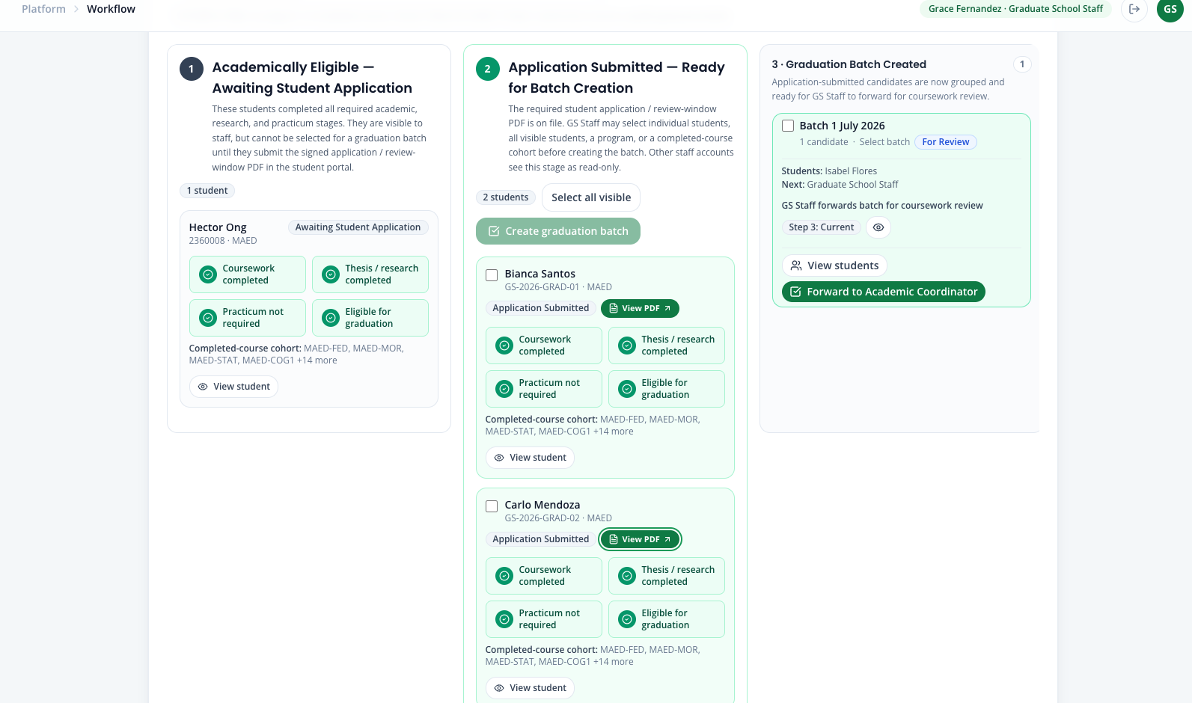
Step 8. Open View student and confirm that the submitted PDF is also available from the student’s case details.
Step 9. Select the red Message / Return button.
Step 10. Set the action to Return for clarification and the recipient to Student.
Step 11. Check Have student resubmit document.
Step 12. Enter: The name and student number in the submitted application do not match the official student record. Upload a corrected signed application.
Step 13. Select the red Return to student button.
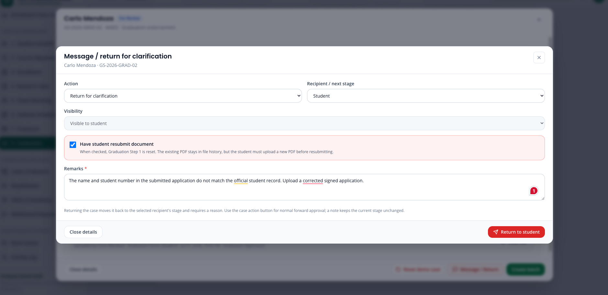
Step 14. Confirm that Carlo moves to Returned for Clarification and cannot be added to a graduation batch.
Step 15. Sign in as Carlo. Open the Request Center and confirm that the newest GS Staff message is highlighted in green.
Step 16. Open Graduation Step 1 and confirm that it has been reset for resubmission.
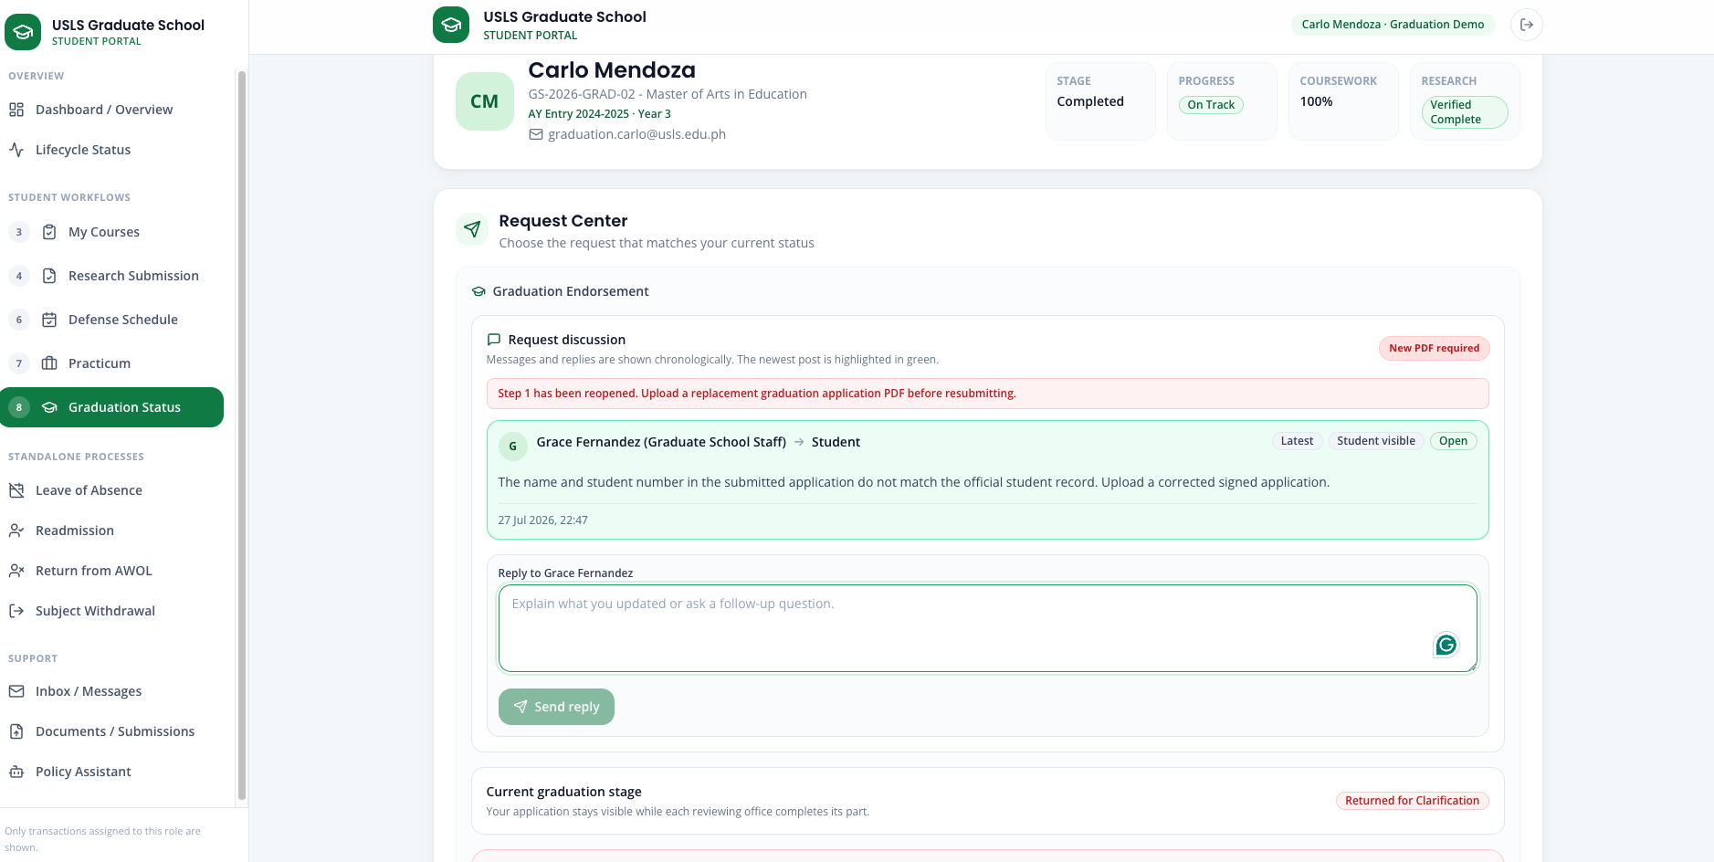
Step 17. Confirm that the incorrect PDF remains visible in the file history but is no longer accepted as the current application.
Step 18. Attempting to reuse the old PDF should be rejected. Upload Carlo_Mendoza_Corrected_Graduation_Application.pdf.
Step 19. Select AY 2026-2027 and select Resubmit graduation application.
Step 20. Sign in as GS Staff. Confirm that Carlo returns to Application Submitted — Ready for Batch Creation with the corrected PDF available through View PDF.
Step 21. Continue Carlo through batch creation, coursework review, research validation, endorsement preparation, Dean approval, and CSV export using the normal steps from Part A.
Screenshot — The Graduation screen with the eligibility check, and the Dean-approved endorsement list ready to export.

Scenario 13 — Standing changes: LOA, Readmission, AWOL return, and Residency
Story:
Standing changes are separate governed flows. Leave of Absence pauses an active student; Readmission restores a student after approved LOA; AWOL is created automatically from explicit source evidence; Return from AWOL requires written intent and a Dean decision; and Residency records valid academic work without subjects.
Accounts used:
Role / demo record | Account
LOA student | Daniel Fernandez — loa.daniel@usls.edu.ph
Readmission student | Therese Lacson — readmission.therese@usls.edu.ph
AWOL return student | Maya Torres — awol.maya@usls.edu.ph
Residency record | Nicolas Valdez — residency.nicolas@usls.edu.ph
Graduate School Staff | staff@usls.edu.ph
Academic Coordinator | academic@usls.edu.ph
Dean / approver | dean@usls.edu.ph
Password | DemoPass123! for every account
Part A — Leave of Absence
Step 1. As Daniel Fernandez, open Leave of Absence and enter the effective start semester, effective end semester, reason category, and remarks. Submit the structured application.
Step 2. As Graduate School Staff, open Leave of Absence, select the submitted request, run the deterministic policy checker, and review the requested period, reason, prior approved leaves, and minimum residency.
Step 3. Complete the staff review and forward the request to the Dean. A policy recommendation supports the review but does not approve the request.
Step 4. As the Dean, open LOA / Readmission / AWOL and approve, deny, or return the case. Approval changes the student to On Leave / LOA and enables the Registrar report.
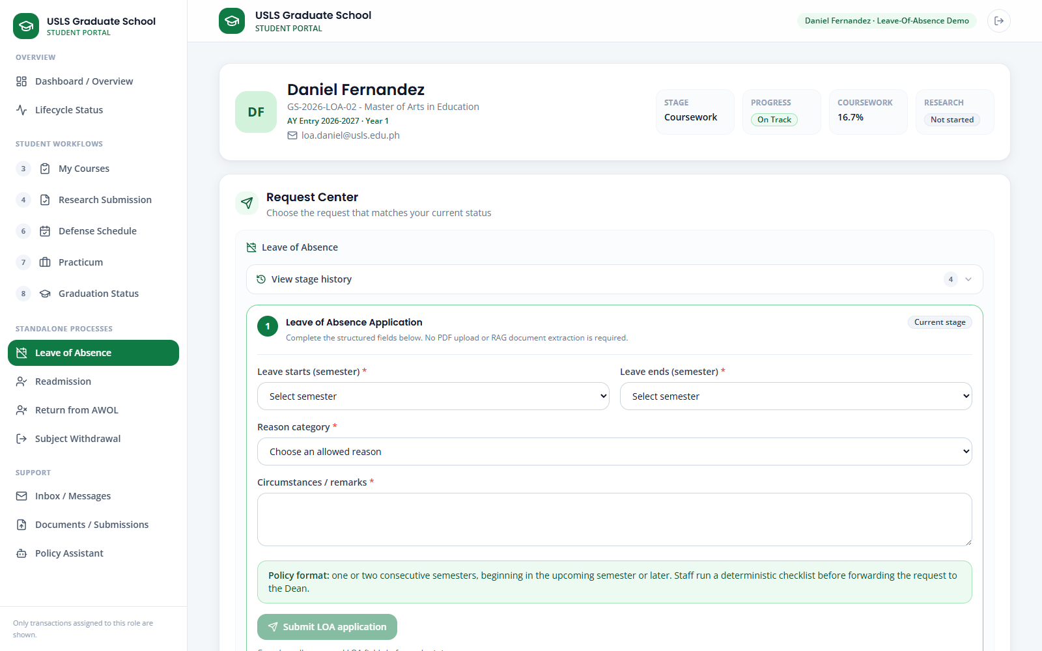
Screenshot — The student's structured Leave of Absence application and timeline.
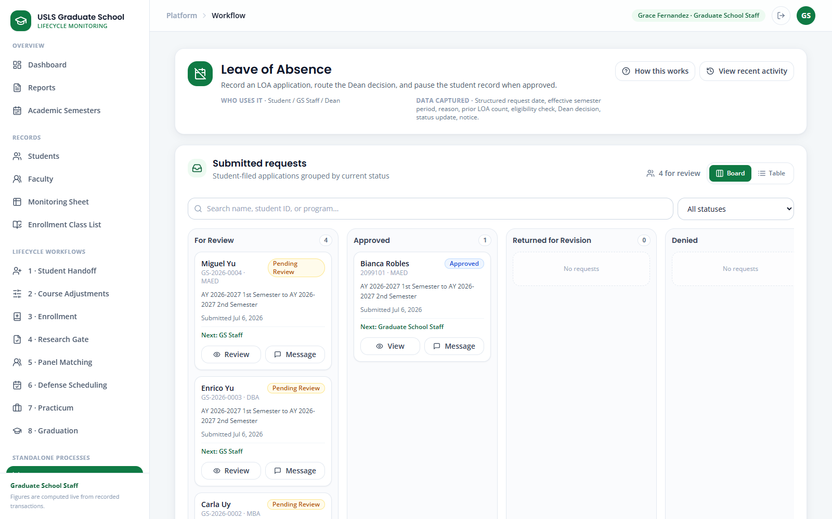
Screenshot — The staff Leave of Absence review workspace with policy checks and routed cases.
Part B — Readmission after approved LOA
Step 5. As Therese Lacson, open Readmission. Choose the return semester and previous LOA start/end, state the intention and readiness to resume, tick all four checklist items, and submit.
Step 6. As Graduate School Staff, open Readmission, run the fixed policy review, record eligibility and missing requirements, then complete the review. Eligible and Needs Review cases are still routed to the Dean.
Step 7. As the Dean, approve, deny, or return the request. Approval restores Active standing with Not Enrolled status; course enrollment remains a separate Academic Coordinator action. Export the Registrar report if needed.
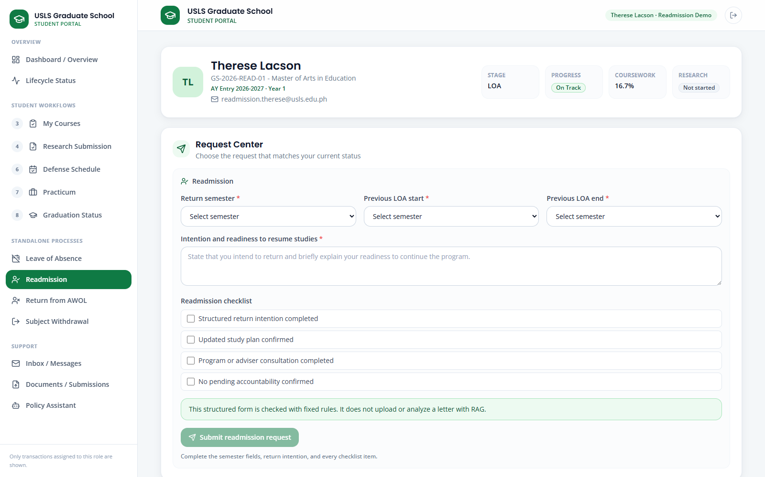
Screenshot — Readmission with return-semester fields, prior LOA period, written intention, and required checklist.
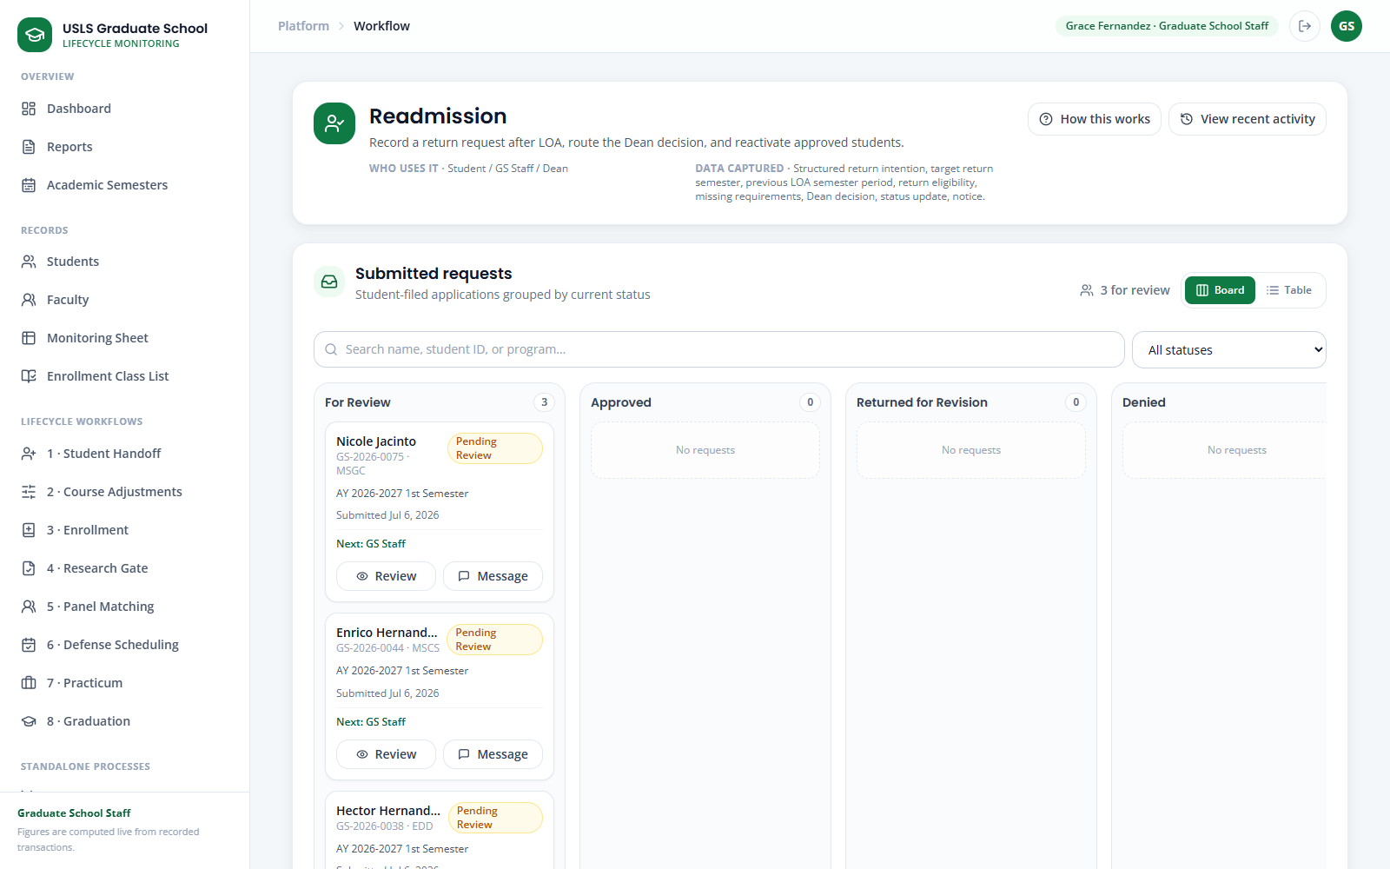
Screenshot — The staff Readmission review, policy result, requirements, notes, and Dean-routing action.
Part C — Automatic AWOL and Return from AWOL
Step 8. Open AWOL & Residency as Staff or Academic Coordinator. Show that AWOL cannot be declared manually: the system creates the case only from an imported AWOL standing or a full-semester withdrawal without approved LOA.
Step 9. As Maya Torres, open Return from AWOL. Confirm the automatically flagged case, choose the intended return semester and last enrolled semester, enter the written intention and return reason, then submit the declaration.
Step 10. As Graduate School Staff, open the AWOL / Return case, run the return policy checker, review years in program and the master's 5/7-year or doctoral 7/9-year residence limits, then forward the declaration to the Dean.
Step 11. As the Dean, approve, deny, or return the declaration. Approval may restore Active / Not Enrolled, require a graded 6-unit refresher during the extension, or route full re-enrollment review when the absolute limit is exceeded.
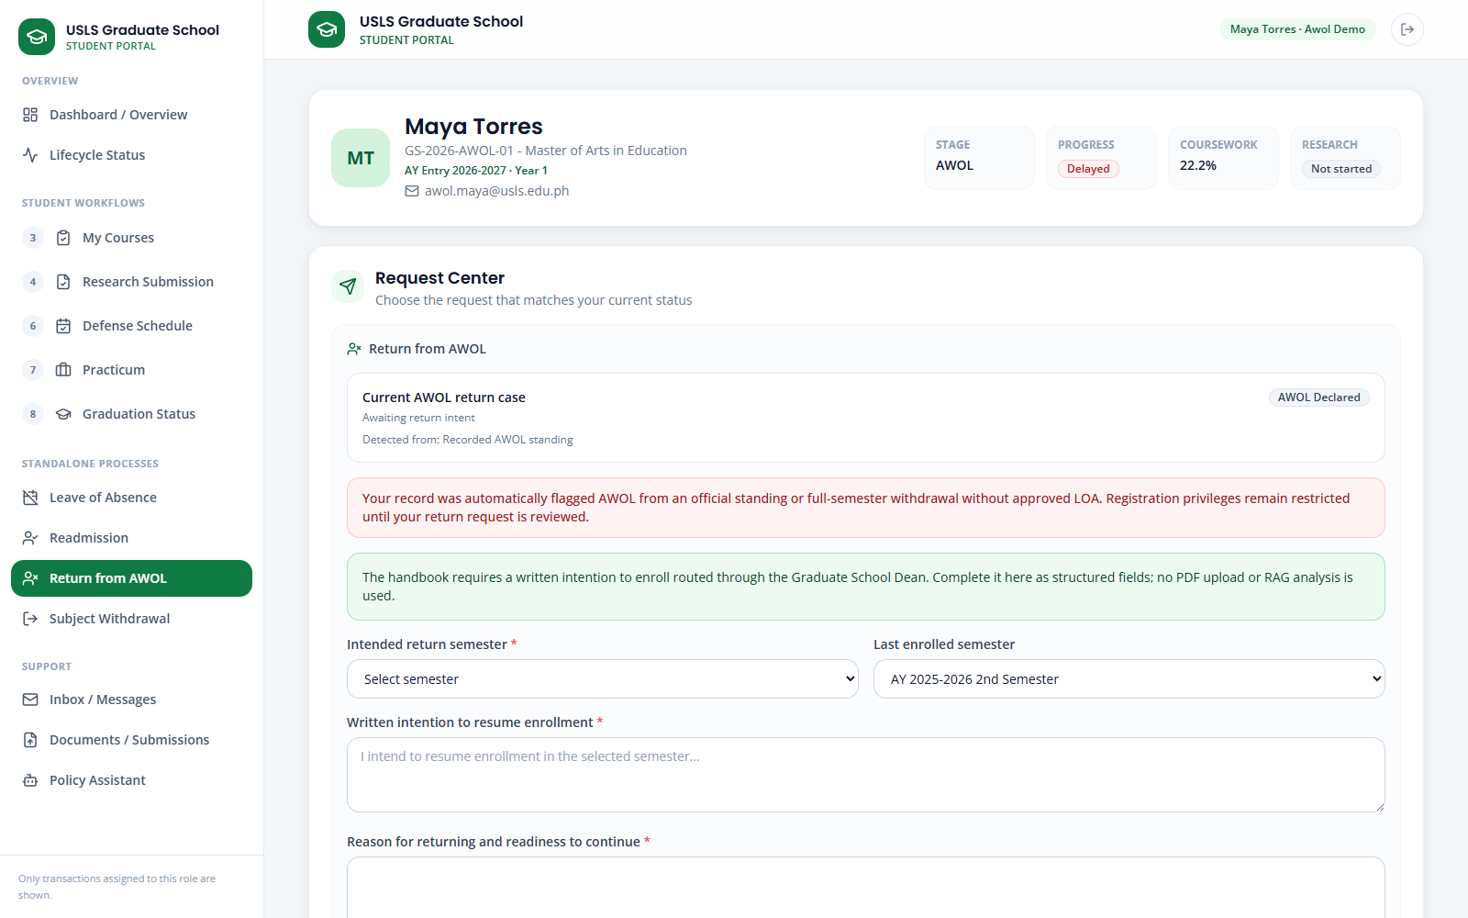
Screenshot — Return from AWOL showing the automatic source flag and the structured written declaration.
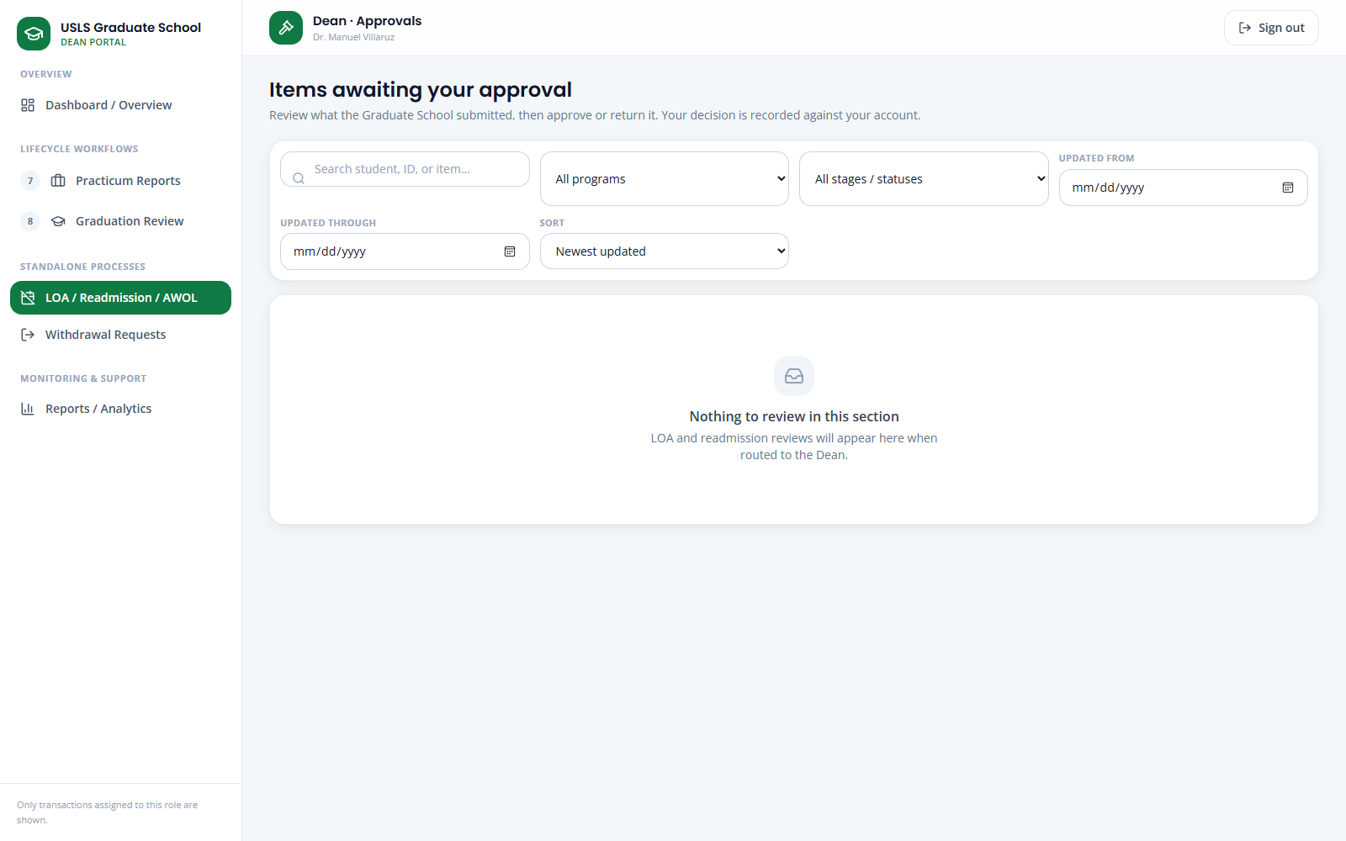
Screenshot — The Dean's LOA / Readmission / AWOL approval queue; routed cases appear here for a recorded decision.
Part D — Residency without subjects
Step 12. As Graduate School Staff or Academic Coordinator, open AWOL & Residency, select Nicolas Valdez, choose the semester and a handbook-supported purpose, and run the residency policy checker.
Step 13. Confirm that the student is active, has no subject enrollment, and is continuing a permitted comprehensive-exam, practicum, thesis/dissertation, or publication activity. Add verification notes when human review is required.
Step 14. Click Record residency. Verify the active Residency tag in the monitoring and term-enrollment records, export the Registrar report if needed, and use Close residency when the period ends.
Note: Residency is not a substitute for LOA, AWOL, withdrawal, or completed standing. A student with remaining course units who will not enroll should use the appropriate LOA process.
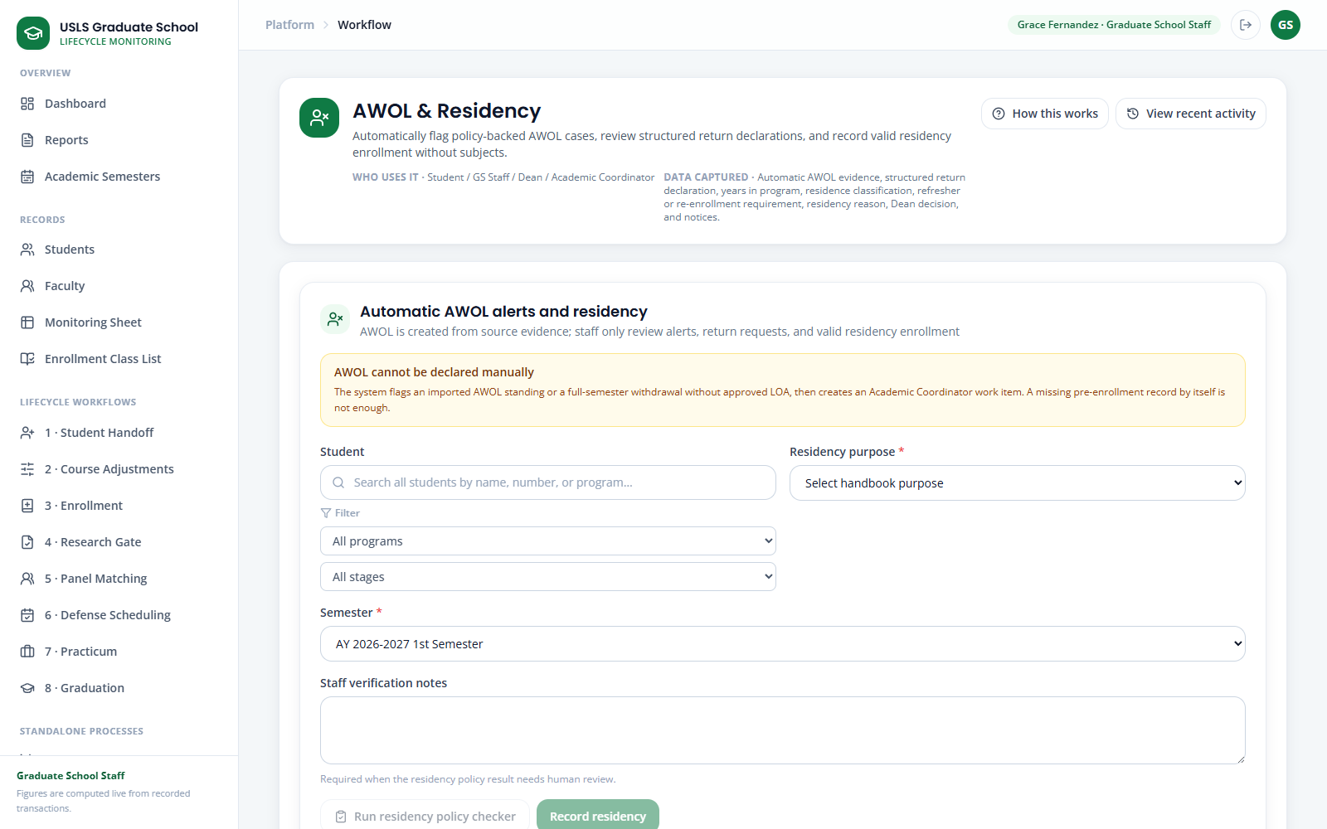
Screenshot — AWOL & Residency showing automatic-AWOL rules and the separate residency policy checker.

7. Honest Notes & Limitations
For an accurate demonstration, keep these points in mind and state them plainly if asked:
- AIMS is a separate, official university system. This portal does not connect to AIMS live; it uses an approved export/import workbook. Imported official values are read-only here, and corrections are made in AIMS and re-imported.
- The application records and displays enrollment; it does not perform official enrollment in place of the Registrar.
- Grades and course-completion come from the official export, not from manual entry inside the portal.
- Risk is shown as Not Yet Assessed for new or incomplete records instead of an invented Low/Medium/High score, until the official risk rules are confirmed.
- Where the portal shows recommendations (subject needs, faculty, panels), they are suggestions with a stated basis that an authorized person confirms.
- The Policy Assistant answers from the provided handbook and research documents; treat it as decision support, not an official ruling.

End of Demonstration Walkthrough

